1. Write a JCL to create a sequential data set using **IEFBR14**.

//DSRP013M JOB 1234,'MONALI',MSGLEVEL=(1,1),

// MSGCLASS=X,CLASS=A,NOTIFY=&SYSUID

//*

//STEP1 EXEC PGM=IEFBR14

//FILE1 DD DSN=DSRP013.TEST.FILE.PS,

// DISP=(MOD,DELETE,DELETE),

// SPACE=(TRK,(1,1),RLSE),

// DCB=(LRECL=80,BLKSIZE=8000,RECFM=FB,DSORG=PS)

//*

//STEP2 EXEC PGM=IEFBR14

//FILE2 DD DSN=DSRP013.TEST.FILE.PS,

// DISP=(MOD,CATLG,DELETE),

// SPACE=(TRK,(1,1),RLSE),

// DCB=(LRECL=80,BLKSIZE=8000,RECFM=FB,DSORG=PS)

/*

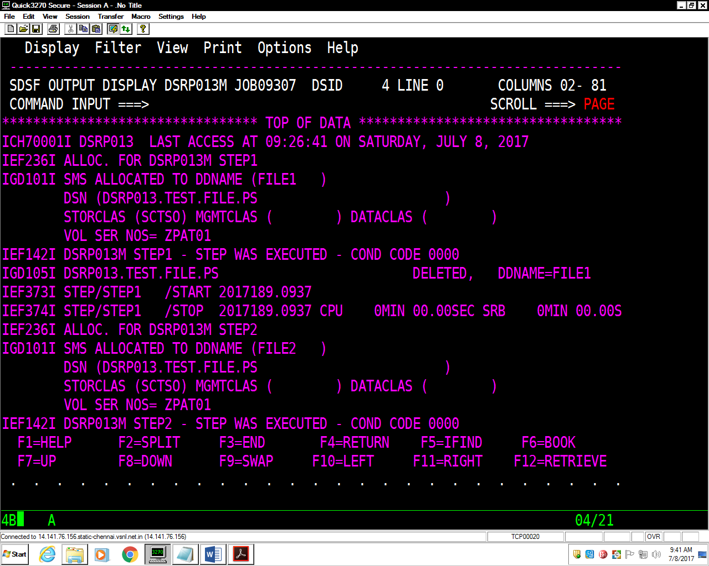

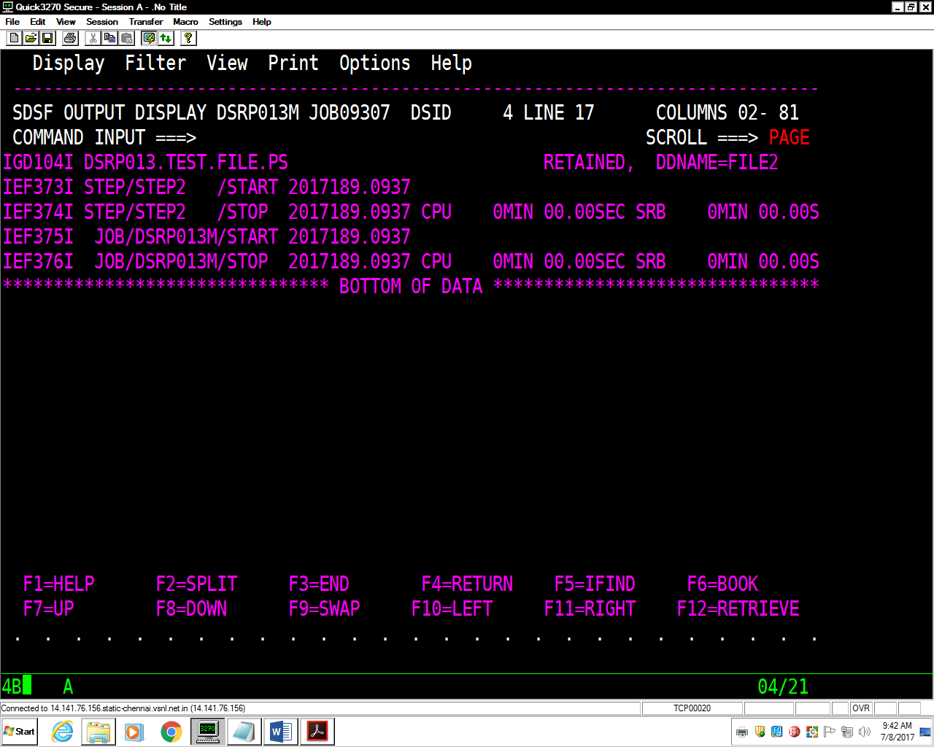

2. Write a JCL to delete a sequential data set using **IEFBR14**.

//DSRP013M JOB 1234,'MONALI',MSGLEVEL=(1,1),

// MSGCLASS=X,CLASS=A,NOTIFY=&SYSUID

//*

//STEP1 EXEC PGM=IEFBR14

//FILE1 DD DSN=DSRP013.TEST.FILE.PS,

// DISP=(MOD,DELETE,DELETE),

// SPACE=(TRK,(1,1),RLSE),

// DCB=(LRECL=80,BLKSIZE=8000,RECFM=FB,DSORG=PS)

/*

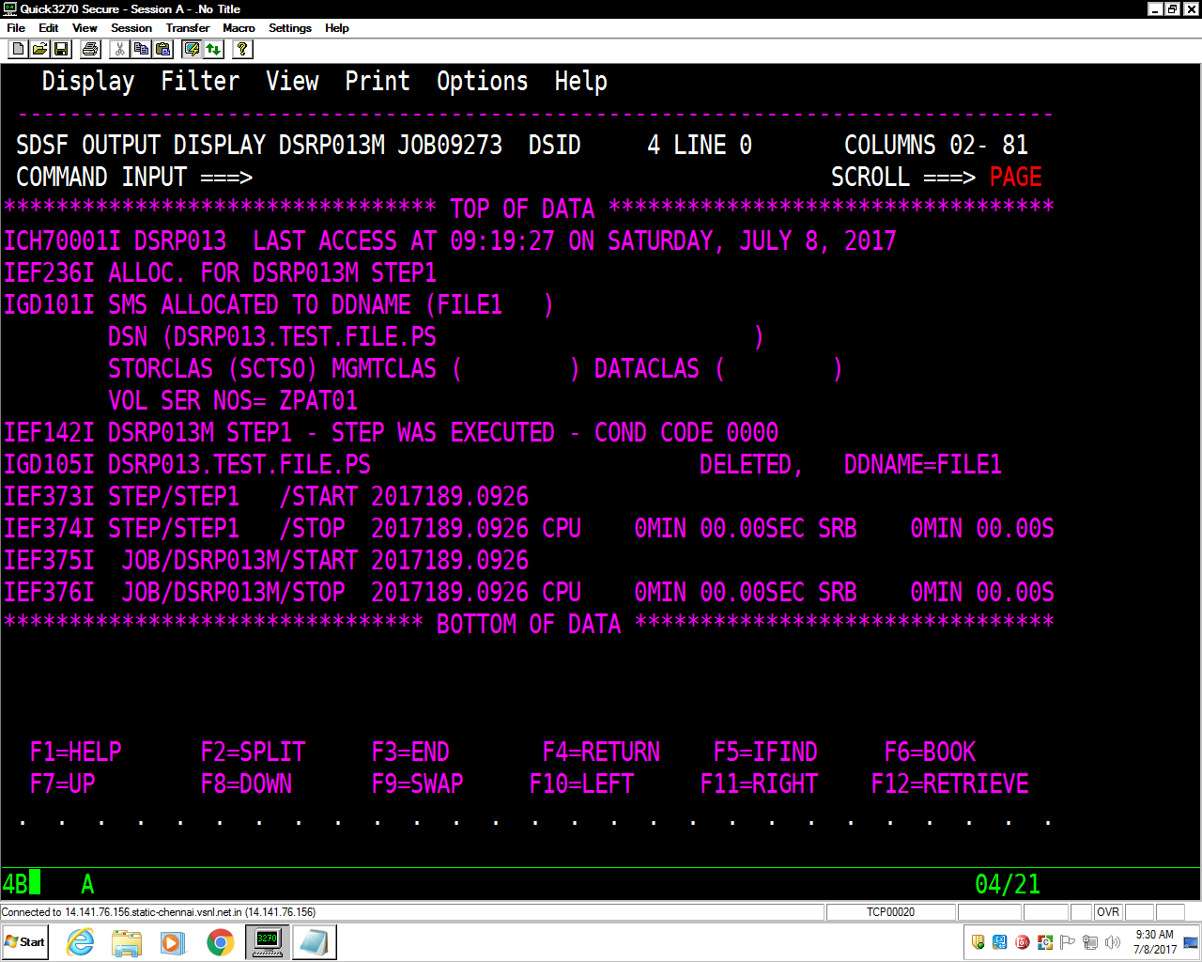

3. Write a JCL for **IEBGENER** to copy from **EMPFILE** into another.

//DSRP013T JOB 1234,'MONALI',MSGLEVEL=(1,1),

// MSGCLASS=X,CLASS=A,NOTIFY=DSRP013

//*

//STEP1 EXEC PGM=IEFBR14

//FILE1 DD DSN=DSRP013.TEST.FILE1,

// DISP=(MOD,DELETE,DELETE),

// SPACE=(TRK,(1,1),RLSE),

// DCB=(LRECL=80,BLKSIZE=8000,RECFM=FB,DSORG=PS)

//*

//STEP2 EXEC PGM=IEBGENER

//SYSUT1 DD DSN=DSRP013.TEST.EMPFILE,DISP=MOD

//SYSUT2 DD DSN=DSRP013.TEST.FILE1,

// DISP=(MOD,CATLG,DELETE),

// SPACE=(TRK,(1,1),RLSE),

// DCB=(LRECL=80,BLKSIZE=8000,RECFM=FB,DSORG=PS)

//SYSPRINT DD SYSOUT=*

//SYSIN DD *

/*

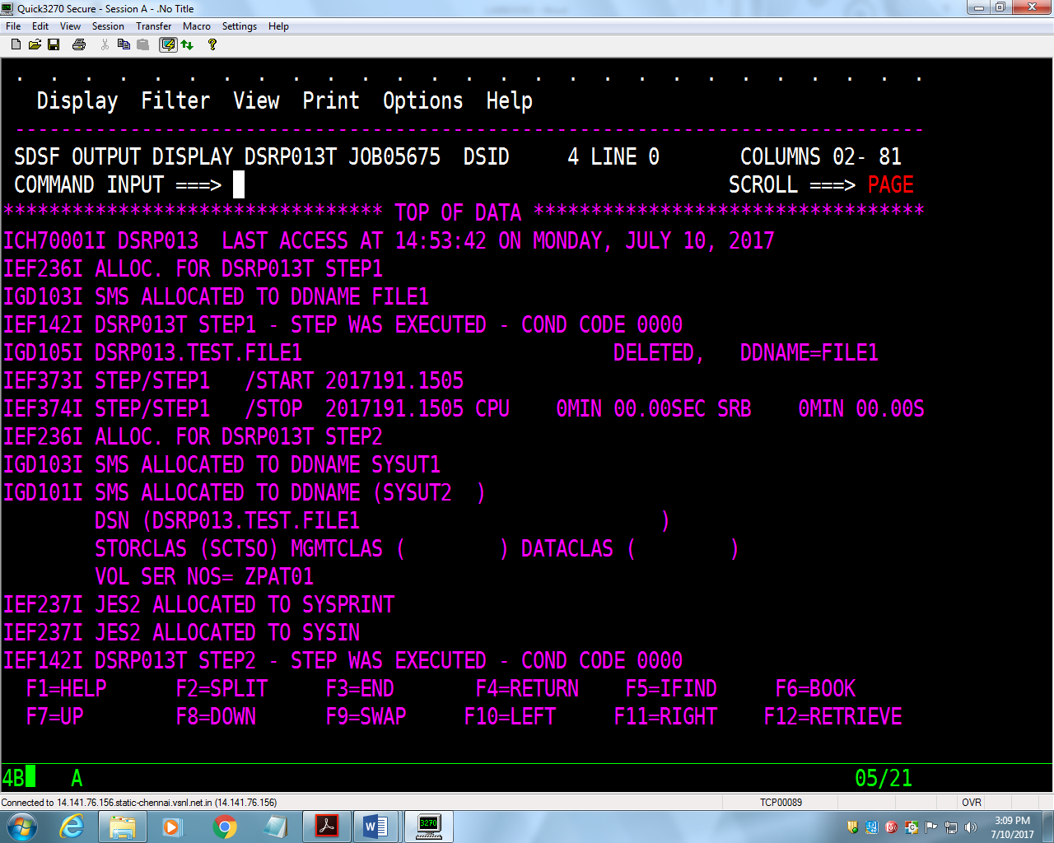

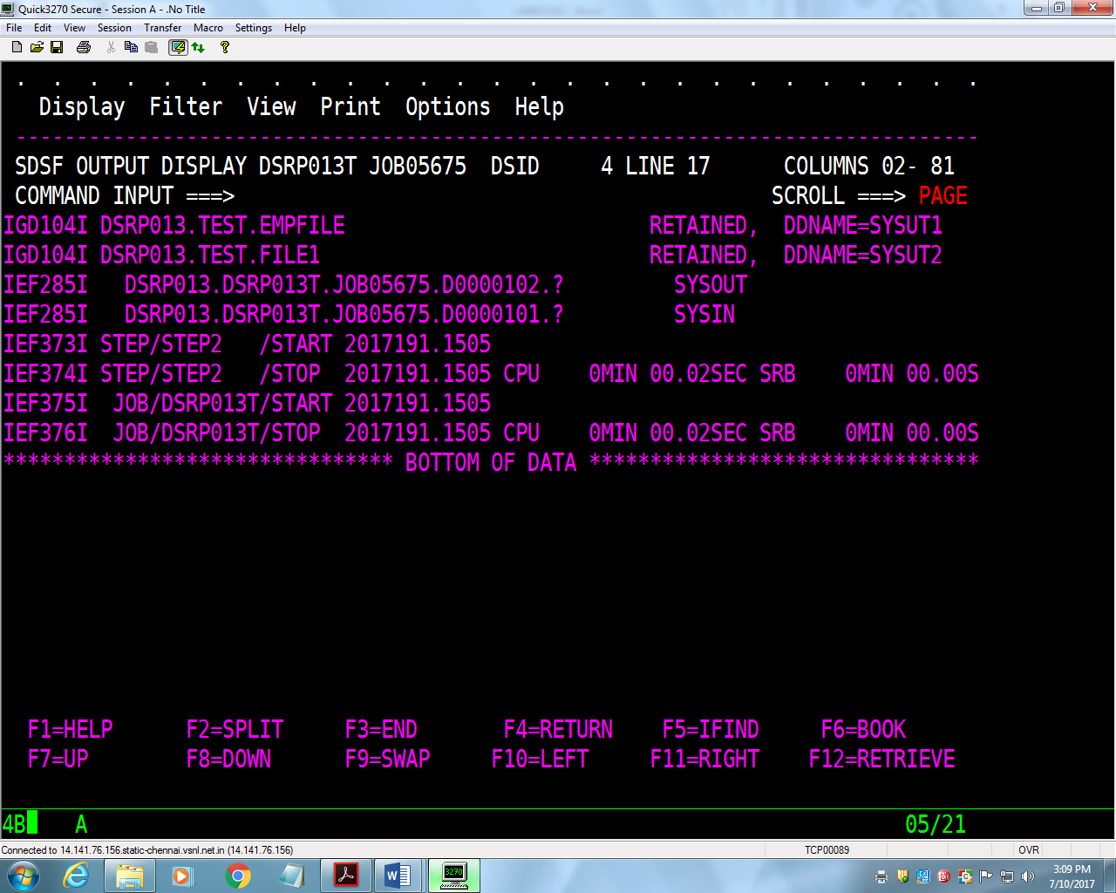

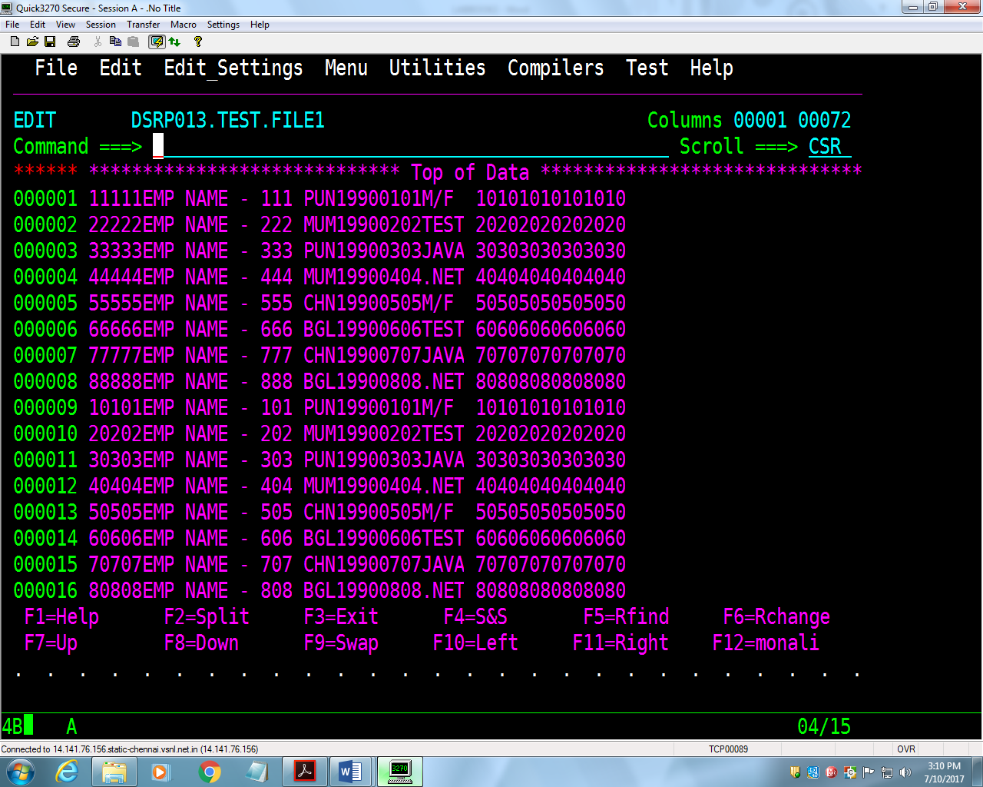

4. Try concatenation of sequential files using **IEBGENER**.

//DSRP013T JOB 1234,'MONALI',MSGLEVEL=(1,1),

// MSGCLASS=X,CLASS=A,NOTIFY=DSRP013

//*

//STEP1 EXEC PGM=IEFBR14

//FILE1 DD DSN=DSRP013.TEST.FILE3,

// DISP=(MOD,DELETE,DELETE),

// SPACE=(TRK,(1,1),RLSE),

// DCB=(LRECL=80,BLKSIZE=8000,RECFM=FB,DSORG=PS)

//*

//STEP2 EXEC PGM=IEBGENER

//SYSUT1 DD DSN=DSRP013.TEST.FILE1,DISP=MOD

// DD DSN=DSRP013.TEST.FILE2,DISP=MOD

//SYSUT2 DD DSN=DSRP013.TEST.FILE3,

// DISP=(MOD,CATLG,DELETE),

// SPACE=(TRK,(1,1),RLSE),

// DCB=(LRECL=80,BLKSIZE=8000,RECFM=FB,DSORG=PS)

//SYSPRINT DD SYSOUT=*

//SYSIN DD *

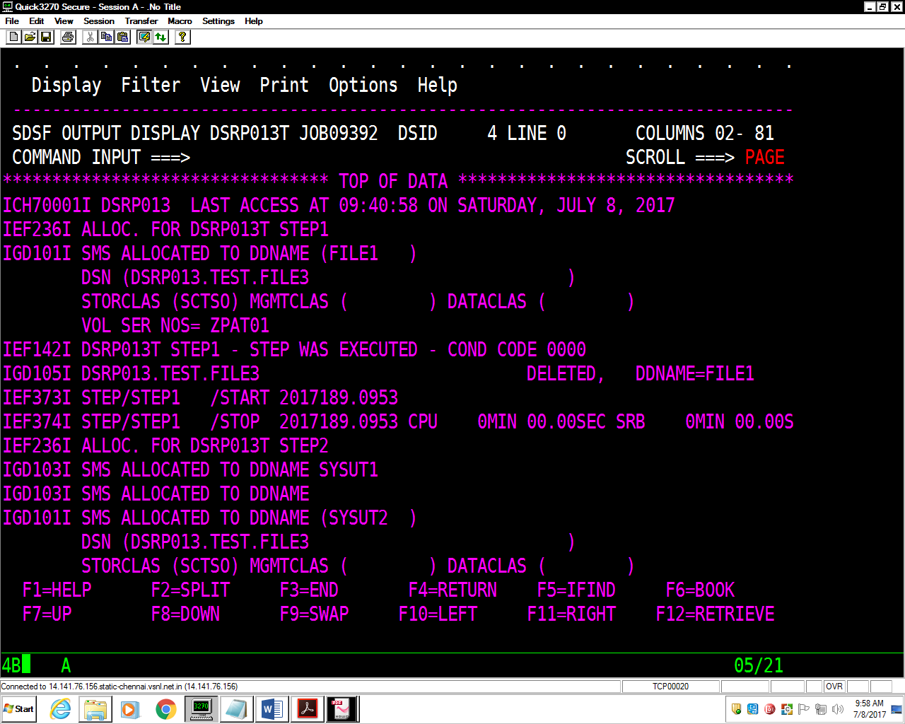

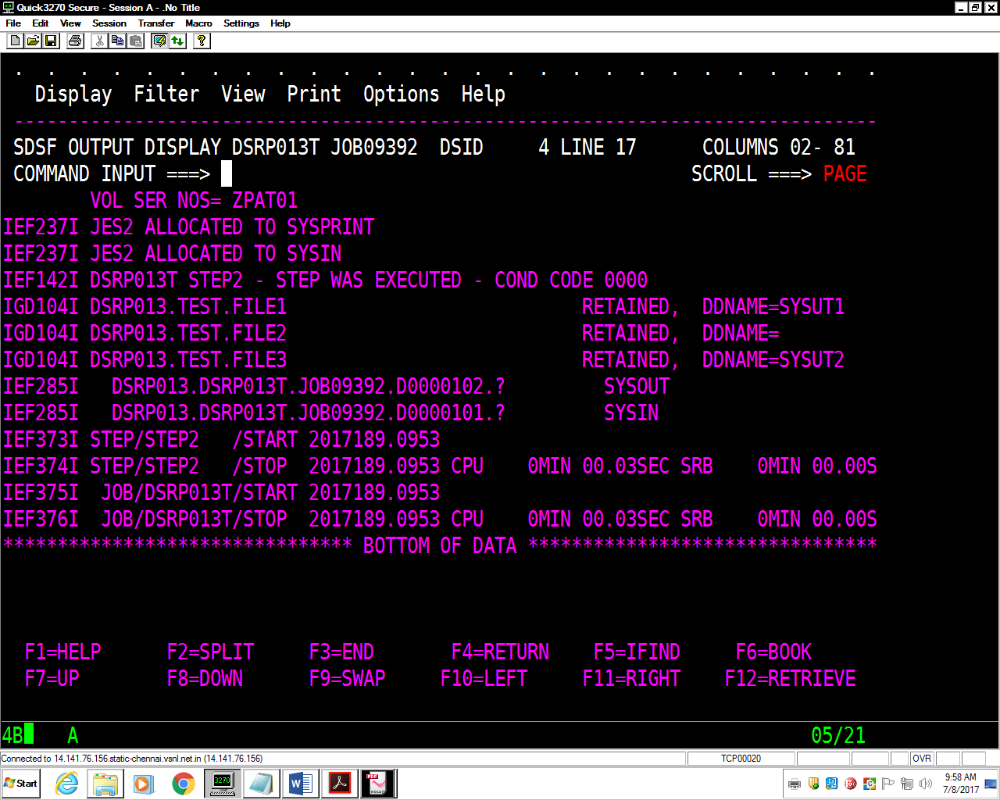

5. Write a JCL to sort the **EMPFILE** in descending or ascending order of **EMP-NO**.

ASCENDING ORDER

//DSRP013M JOB 1234,'MONALI',MSGLEVEL=(1,1),

// MSGCLASS=X,CLASS=A,NOTIFY=&SYSUID

//*

//STEP010 EXEC PGM=IEFBR14

//FILE1 DD DSN=DSRP013.TEST.SORT1,

// DISP=(MOD,DELETE,DELETE),

// SPACE=(TRK,(1,1),RLSE),

// DCB=(LRECL=80,BLKSIZE=8000,RECFM=FB,DSORG=PS)

//*

//STEP020 EXEC PGM=SORT

//SORTIN DD DSN=DSRP013.TEST.EMPFILE,DISP=OLD

//SORTOUT DD DSN=DSRP013.TEST.SORT1,

// DISP=(NEW,CATLG,DELETE),

// SPACE=(TRK,(1,1),RLSE),

// DCB=(LRECL=80,BLKSIZE=8000,RECFM=FB,DSORG=PS)

//SORTWK01 DD SPACE=(TRK,(1,1),RLSE),UNIT=SYSDA

//SYSOUT DD SYSOUT=*

//SYSIN DD *

SORT FIELDS=(1,5,CH,A),EQUALS

/*

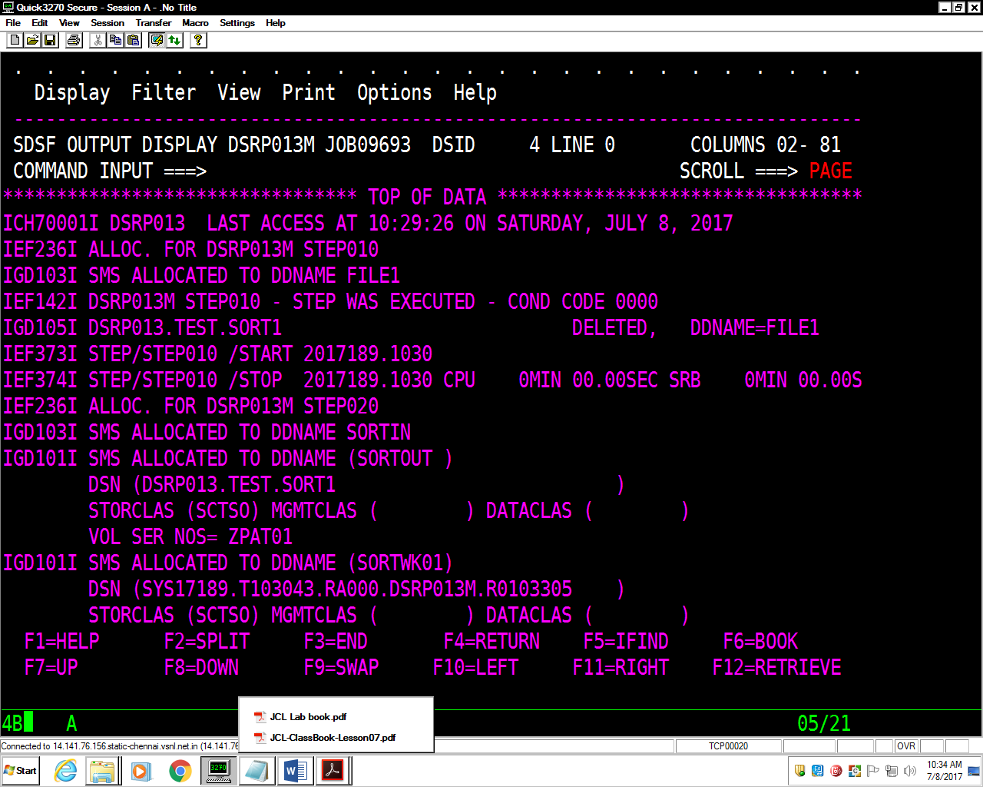

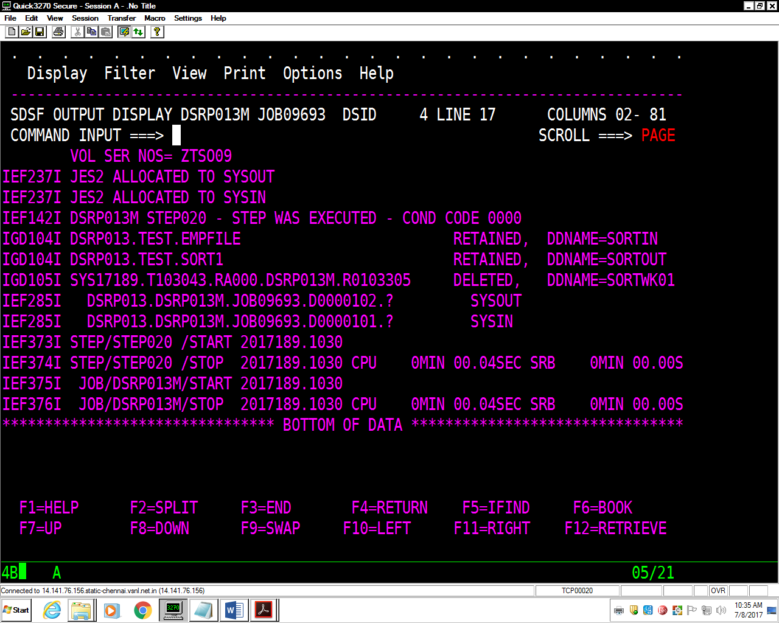

DESCENDING ORDER

//DSRP013M JOB 1234,'MONALI',MSGLEVEL=(1,1),

// MSGCLASS=X,CLASS=A,NOTIFY=&SYSUID

//*

//STEP010 EXEC PGM=IEFBR14

//FILE1 DD DSN=DSRP013.TEST.SORT2,

// DISP=(MOD,DELETE,DELETE),

// SPACE=(TRK,(1,1),RLSE),

// DCB=(LRECL=80,BLKSIZE=8000,RECFM=FB,DSORG=PS)

//*

//STEP020 EXEC PGM=SORT

//SORTIN DD DSN=DSRP013.TEST.EMPFILE,DISP=OLD

//SORTOUT DD DSN=DSRP013.TEST.SORT2,

// DISP=(NEW,CATLG,DELETE),

// SPACE=(TRK,(1,1),RLSE),

// DCB=(LRECL=80,BLKSIZE=8000,RECFM=FB,DSORG=PS)

//SORTWK01 DD SPACE=(TRK,(1,1),RLSE),UNIT=SYSDA

//SYSOUT DD SYSOUT=*

//SYSIN DD *

SORT FIELDS=(1,5,CH,D),EQUALS

/*

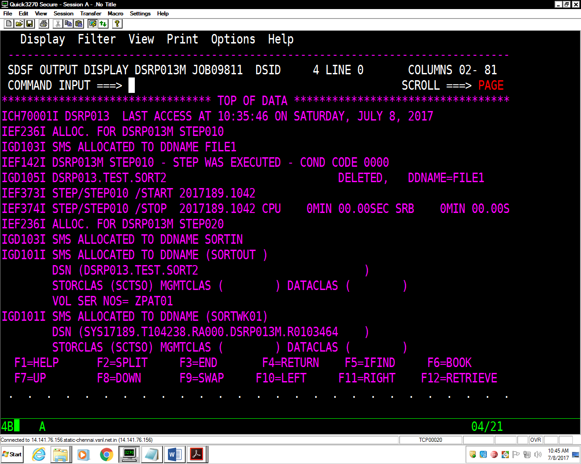

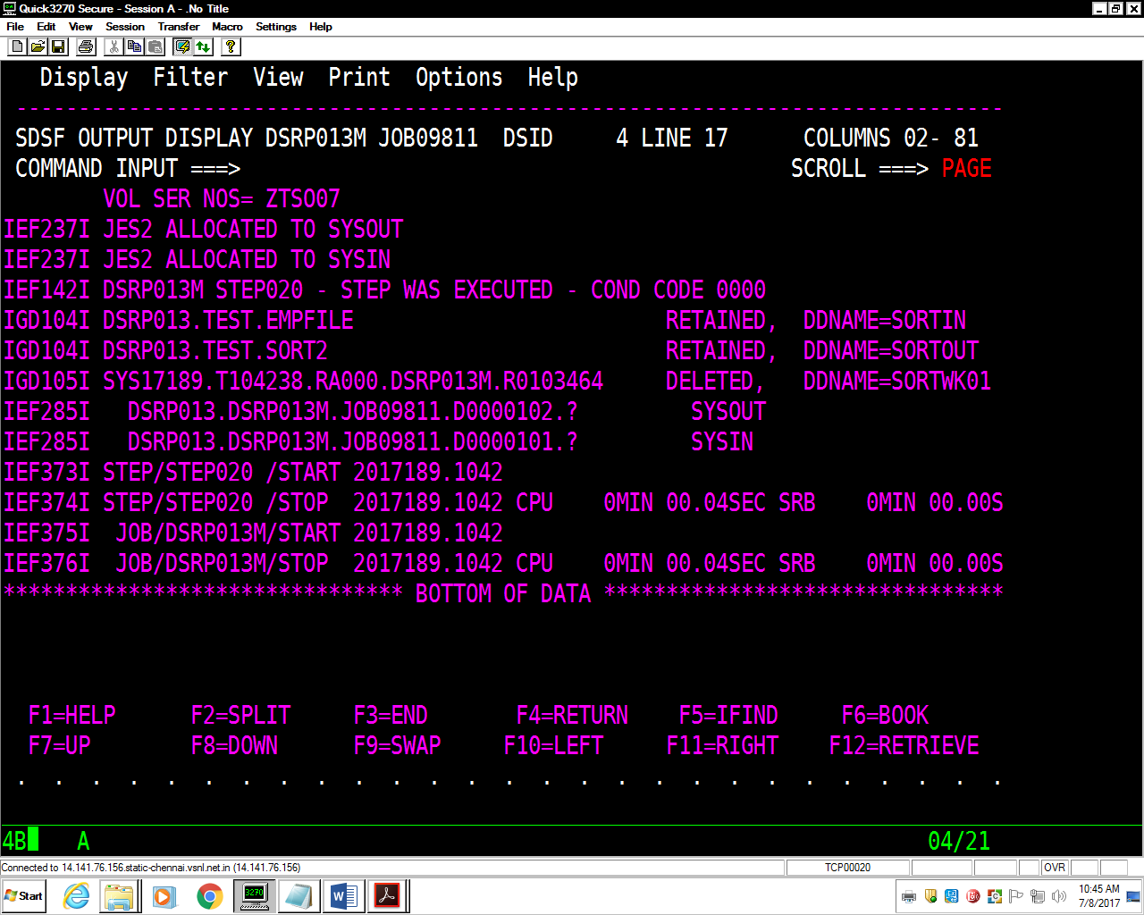

6. Try all the parameters for Sort, namely, INREC, OUTREC, SUM fields.

INREC

//DSRP013M JOB 1234,'MONALI',MSGLEVEL=(1,1),

// MSGCLASS=X,CLASS=A,NOTIFY=&SYSUID

//*

//STEP1 EXEC PGM=IEFBR14

//FILE1 DD DSN=DSRP013.TEST.SORT.INR,

// DISP=(MOD,DELETE,DELETE),

// SPACE=(TRK,(1,1),RLSE),

// DCB=(LRECL=80,BLKSIZE=8000,RECFM=FB,DSORG=PS)

//*

//STEP2 EXEC PGM=SORT

//SORTIN DD DSN=DSRP013.TEST.EMPFILE,DISP=OLD

//SORTOUT DD DSN=DSRP013.TEST.SORT.INR,

// DISP=(NEW,CATLG,DELETE),

// SPACE=(TRK,(1,1),RLSE),

// DCB=(LRECL=80,BLKSIZE=8000,RECFM=FB,DSORG=PS)

//SORTWK01 DD SPACE=(CYL,(1,1),RLSE),UNIT=SYSDA

//SYSOUT DD SYSOUT=*

//SYSIN DD *

INREC FIELDS=(1:32,5,6:1,5,11:6,15,26:21,3,29:24,8,38:37,14)

SORT FIELDS=(6,5,CH,A)

/*

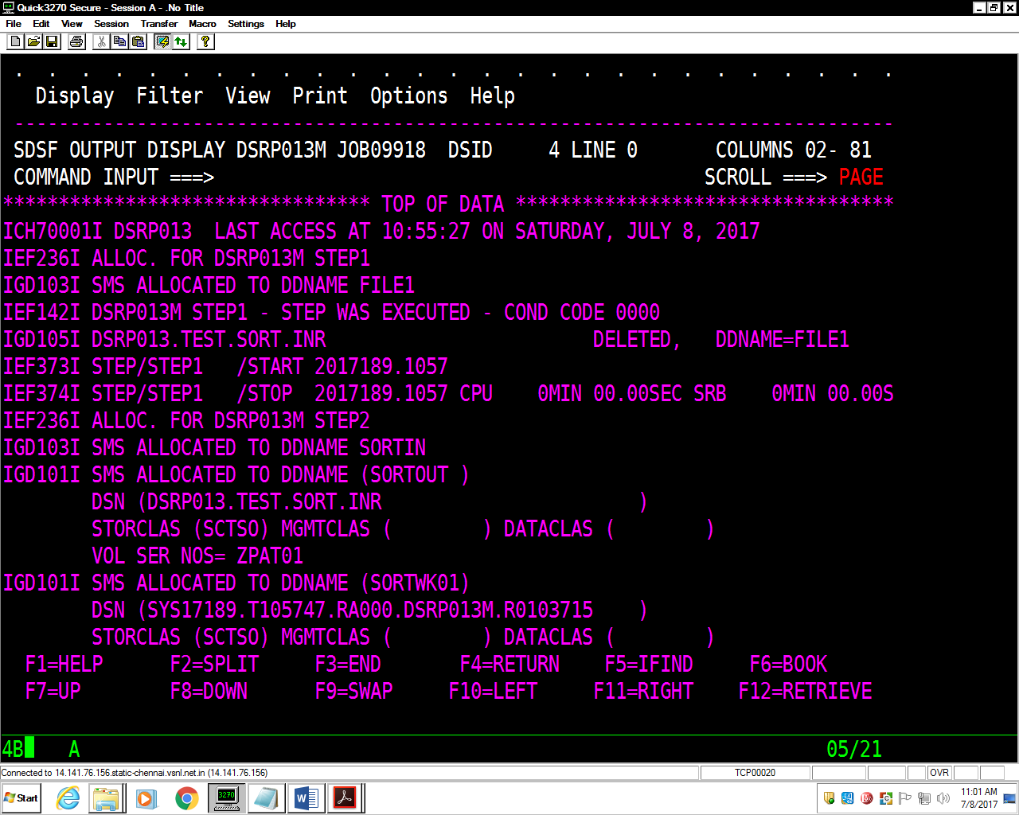

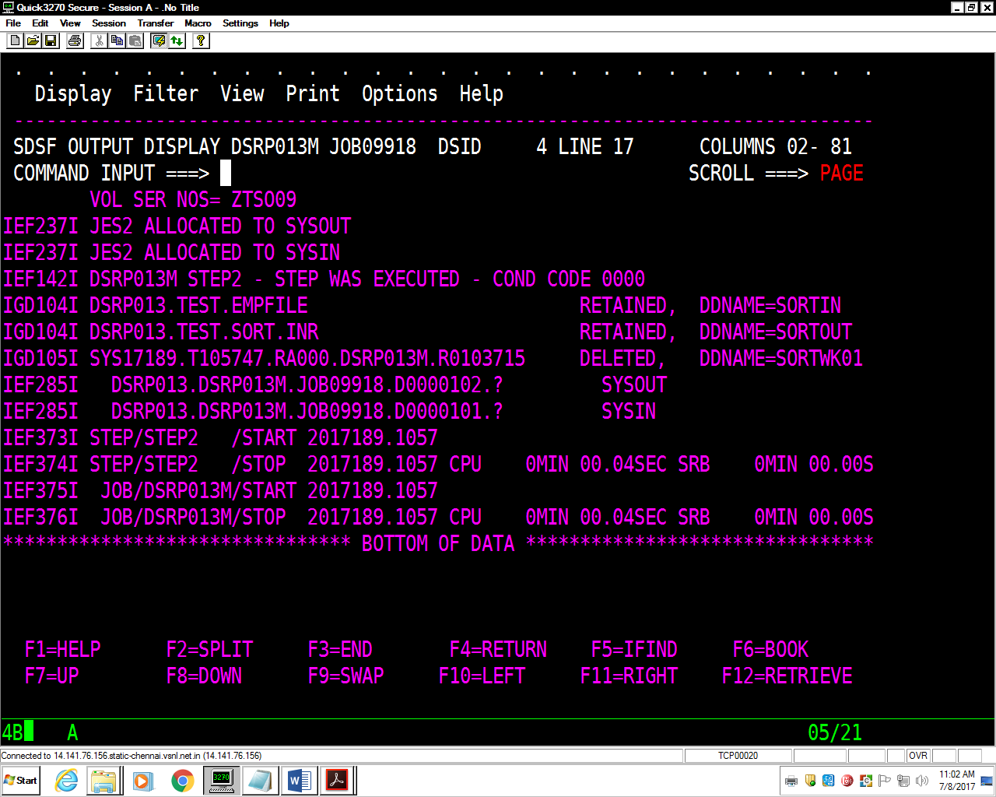

OUTREC

//DSRP013C JOB ABCD,'CAP GEMINI',MSGLEVEL=(1,1),

// MSGCLASS=X,CLASS=A,NOTIFY=&SYSUID

//*

//STEP010 EXEC PGM=IEFBR14

//FILE1 DD DSN=DSRP013.TEST.SORT.OUT,

// DISP=(MOD,DELETE,DELETE),

// SPACE=(TRK,(1,1),RLSE),

// DCB=(LRECL=80,BLKSIZE=8000,RECFM=FB,DSORG=PS)

//*

//STEP020 EXEC PGM=SORT

//SORTIN DD DSN=DSRP013.TEST.EMPFILE,DISP=OLD

//SORTOUT DD DSN=DSRP013.TEST.SORT.OUT,

// DISP=(NEW,CATLG,DELETE),

// SPACE=(TRK,(1,1),RLSE),

// DCB=(LRECL=80,BLKSIZE=8000,RECFM=FB,DSORG=PS)

//SORTWK01 DD SPACE=(CYL,(1,1),RLSE),UNIT=SYSDA

//SYSOUT DD SYSOUT=*

//SYSIN DD *

SORT FIELDS=(6,5,CH,A)

OUTREC FIELDS=(1:32,5,2X,8:1,5,2X,15:6,15,2X,32:21,3,2X,37:24,8,35X)

/*

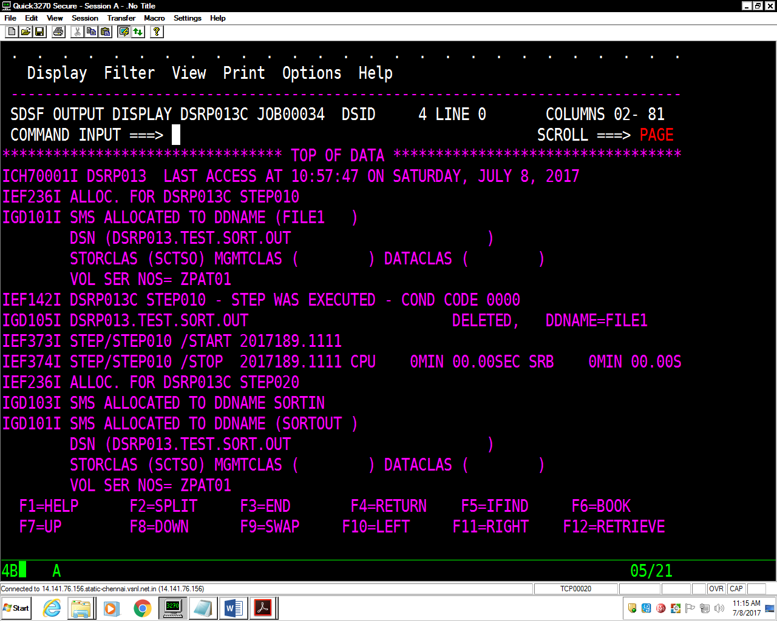

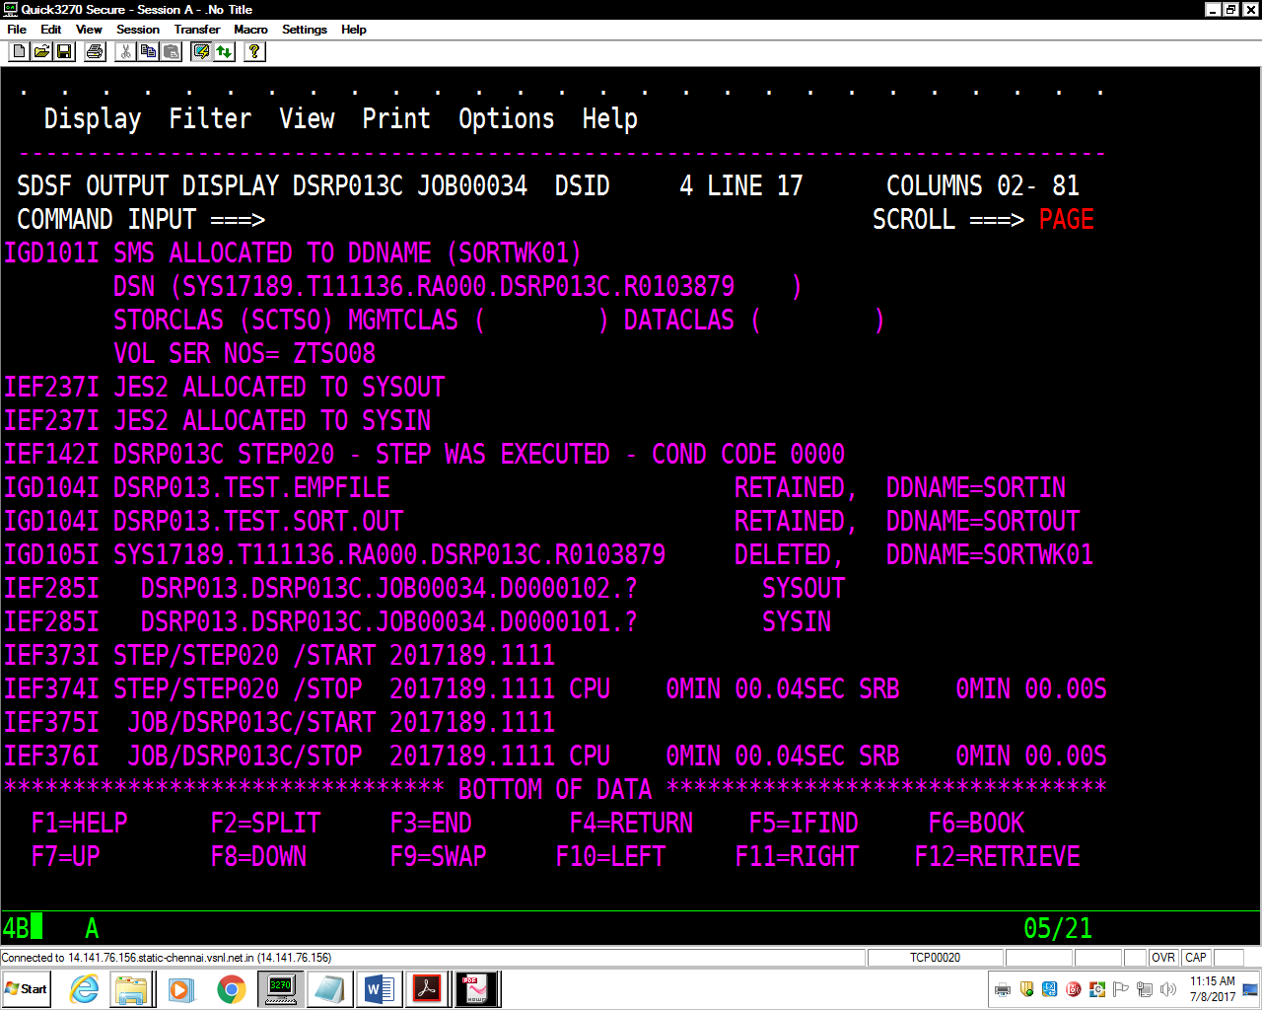

SUM FIELDS

//DSRP013C JOB ABCD,'CAP GEMINI',MSGLEVEL=(1,1),

// MSGCLASS=X,CLASS=A,NOTIFY=&SYSUID

//*

//STEP010 EXEC PGM=IEFBR14

//FILE1 DD DSN=DSRP013.TEST.SORT.SUM,

// DISP=(MOD,DELETE,DELETE),

// SPACE=(TRK,(1,1),RLSE),

// DCB=(LRECL=80,BLKSIZE=8000,RECFM=FB,DSORG=PS)

//*

//STEP020 EXEC PGM=SORT

//SORTIN DD DSN=DSRP013.TEST.EMPFILE,DISP=OLD

//SORTOUT DD DSN=DSRP013.TEST.SORT.SUM,

// DISP=(NEW,CATLG,DELETE),

// SPACE=(TRK,(1,1),RLSE),

// DCB=(LRECL=80,BLKSIZE=8000,RECFM=FB,DSORG=PS)

//SORTWK01 DD SPACE=(CYL,(1,1),RLSE),UNIT=SYSDA

//SYSOUT DD SYSOUT=*

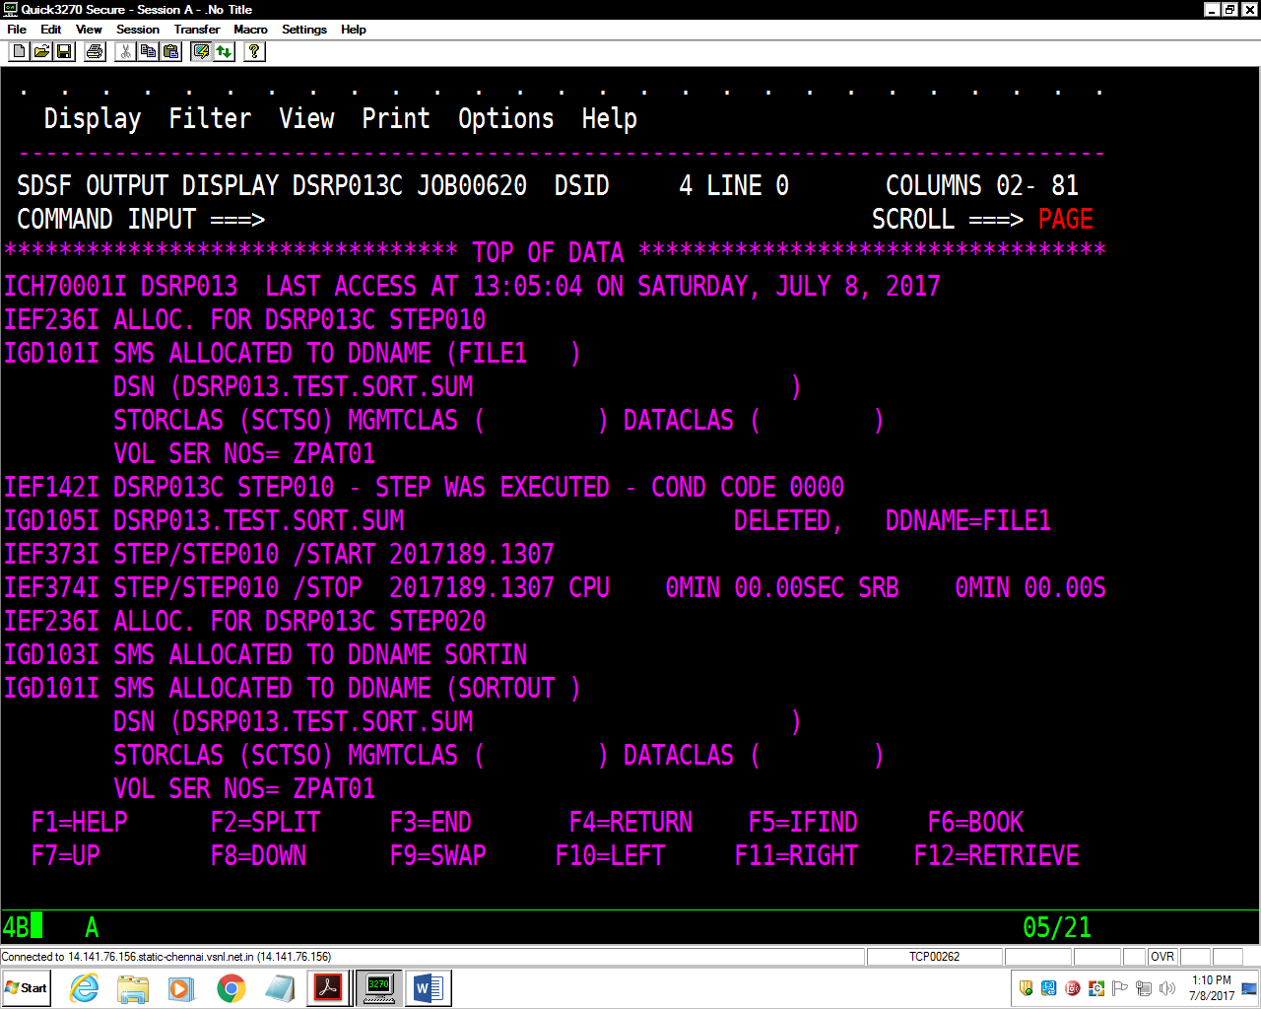  
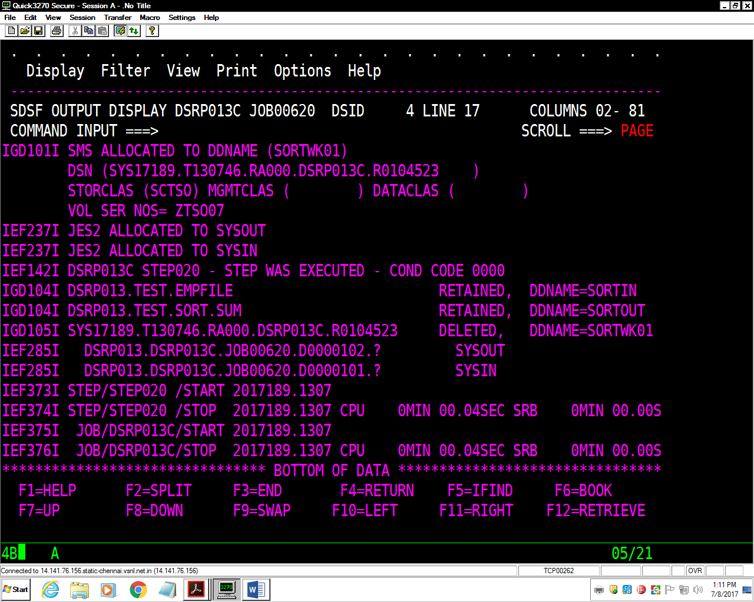

7. Create a PS Dept which includes (Deptno,DeptName,Loc) & list all the distinct

Departments in Ascending order from the Dept File

//DSRP013M JOB 1234,'MONALI',MSGLEVEL=(1,1),

// MSGCLASS=X,CLASS=A,NOTIFY=&SYSUID

//*

//STEP010 EXEC PGM=IEFBR14

//FILE1 DD DSN=DSRP013.TEST.DEPT,

// DISP=(MOD,DELETE,DELETE),

// SPACE=(TRK,(1,1),RLSE),

// DCB=(LRECL=80,BLKSIZE=8000,RECFM=FB,DSORG=PS)

//*

//STEP020 EXEC PGM=SORT

//SORTIN DD DSN=DSRP013.TEST.PS.DEPT,DISP=OLD

//SORTOUT DD DSN=DSRP013.TEST.DEPT,

// DISP=(NEW,CATLG,DELETE),

// SPACE=(TRK,(1,1),RLSE),

// DCB=(LRECL=80,BLKSIZE=8000,RECFM=FB,DSORG=PS)

//SORTWK01 DD SPACE=(TRK,(1,1),RLSE),UNIT=SYSDA

//SYSOUT DD SYSOUT=*

//SYSIN DD *

SORT FIELDS=(1,3,CH,A)

/*

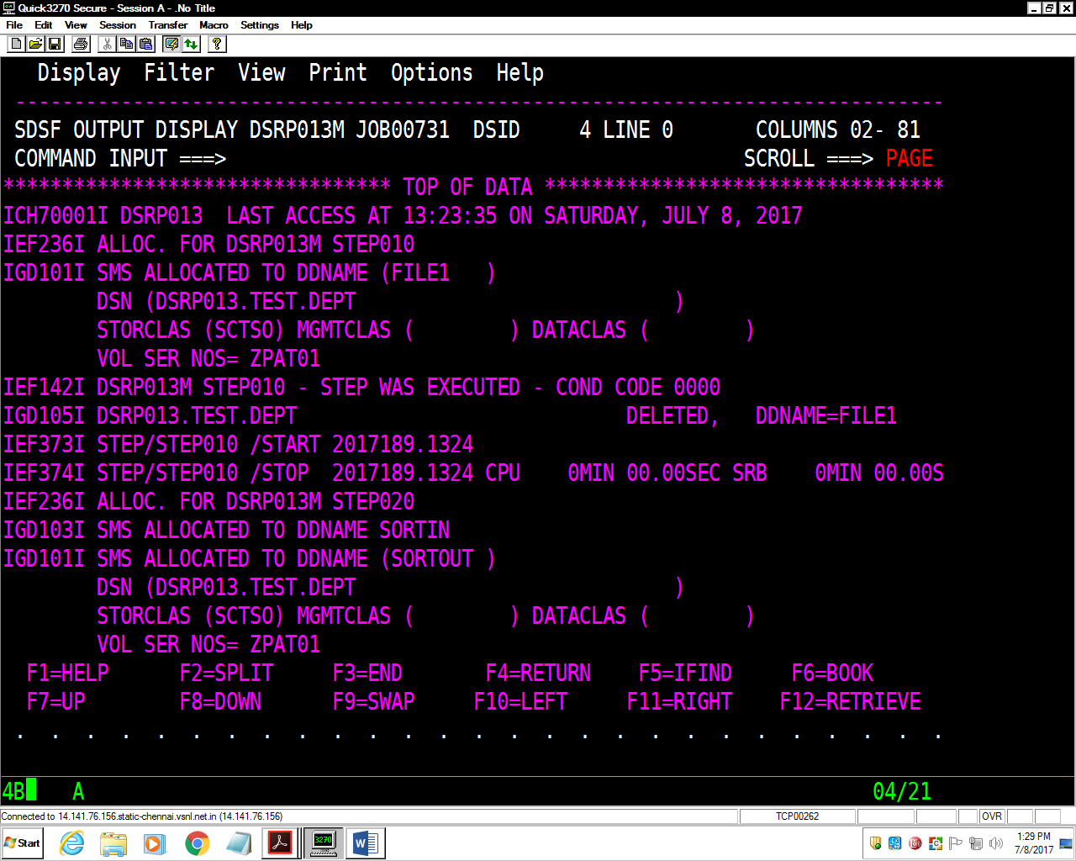

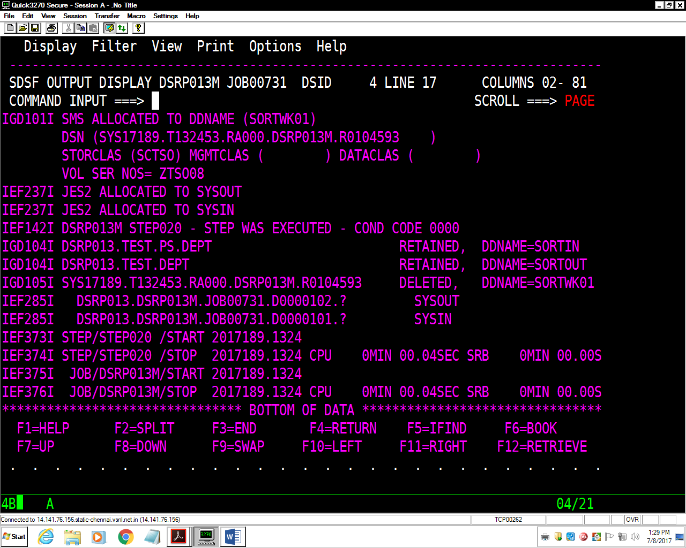

8. Write a cataloged procedure for invoking either **IEFBR14** or **IEBGENER** or

**SORT** utility.

**PROCEDURE**

//PROC1 PROC

//*

//PSTEP1 EXEC PGM=IEFBR14

//FILE1 DD DSN=DSRP013.TEST.ASV1,

// DISP=(MOD,DELETE,DELETE),

// SPACE=(TRK,(1,1),RLSE),

// DCB=(LRECL=80,BLKSIZE=8000,RECFM=FB,DSORG=PS)

//*

//PSTEP2 EXEC PGM=IEFBR14

//FILE1 DD DSN=DSRP013.TEST.ASV1,

// DISP=(NEW,CATLG,DELETE),

// SPACE=(TRK,(1,1),RLSE),

// DCB=(LRECL=80,BLKSIZE=8000,RECFM=FB,DSORG=PS)

// PEND

**JCL**

//DSRP013M JOB 1234,'MONALI',MSGLEVEL=(1,1),

// MSGCLASS=X,CLASS=A,NOTIFY=&SYSUID

//PROCLIB JCLLIB ORDER=(DSRP013.TEST.PROCLIB)

//*THIS LINE SHOWS THE PATH FOR THE PROCEDURE USED

//JSTEP1 EXEC PROC=PROC1

//*

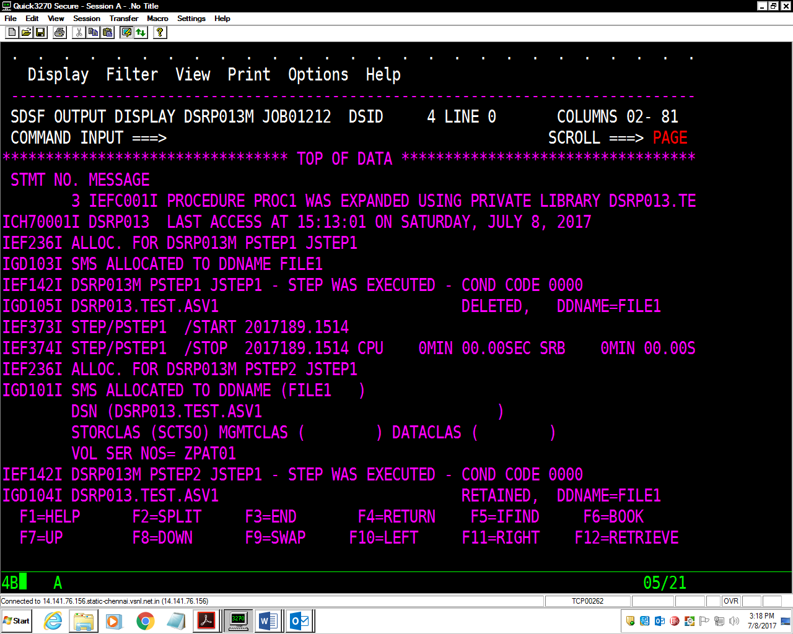

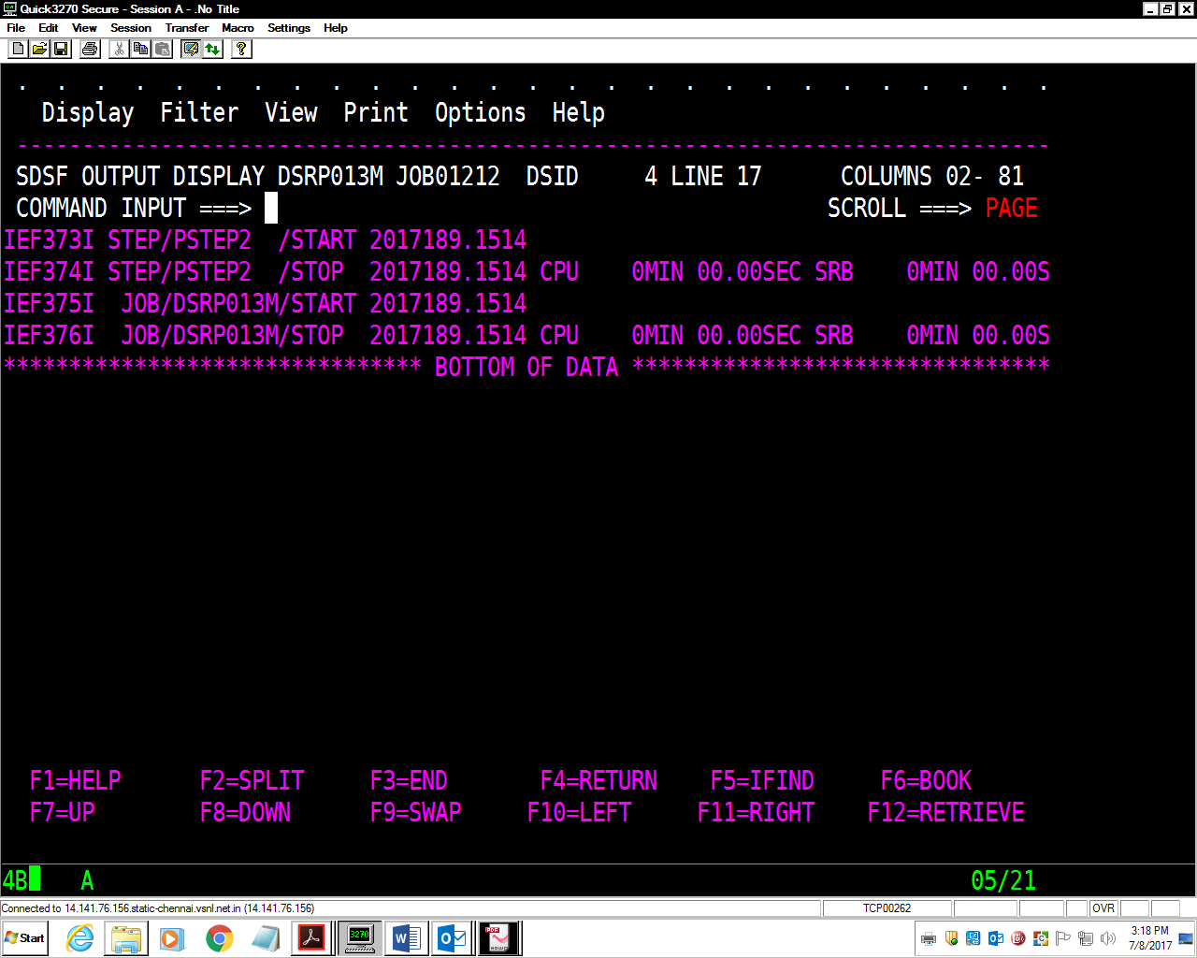

**9. Write an instream procedure for the assignment 7.**

**JCL**

//DSRP013T JOB 1234,'MONALI',MSGLEVEL=(1,1),

// MSGCLASS=X,CLASS=A,NOTIFY=&SYSUID

//IPROC1 PROC DEPT=DEPT

//* IPROC1 IS AN INSTREAM PROCEDURE

//PSTEP1 EXEC PGM=IEFBR14

//FILE1 DD DSN=DSRP013.PS.&DEPT,

// DISP=(MOD,DELETE,DELETE),

// SPACE=(TRK,(1,1),RLSE),

// DCB=(LRECL=80,BLKSIZE=8000,RECFM=FB,DSORG=PS)

//*

//PSTEP2 EXEC PGM=SORT

//SORTIN DD DSN=DSRP013.TEST.PS.DEPT,DISP=OLD

//SORTOUT DD DSN=DSRP013.PS.&DEPT,DISP=(NEW,CATLG,DELETE),

// SPACE=(TRK,(1,1),RLSE),

// DCB=(LRECL=80,BLKSIZE=8000,RECFM=FB,DSORG=PS)

//SORTWK01 DD SPACE=(CYL,(1,1),RLSE),UNIT=SYSDA

//SYSOUT DD SYSOUT=*

//SYSIN DD DSN=DSRP013.TEST.PARMLIB(SORT),DISP=SHR

// PEND

//*

//JSTEP1 EXEC IPROC1,DEPT=FIRST

PARMLIB

SORT FIELDS=(1,2,CH,A)

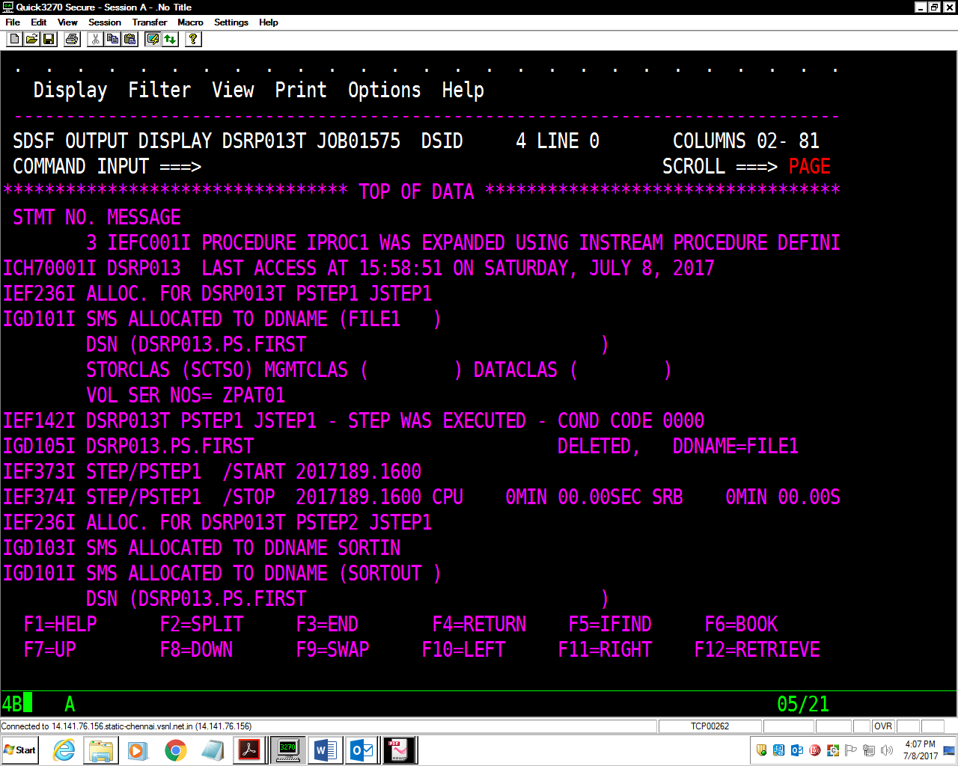

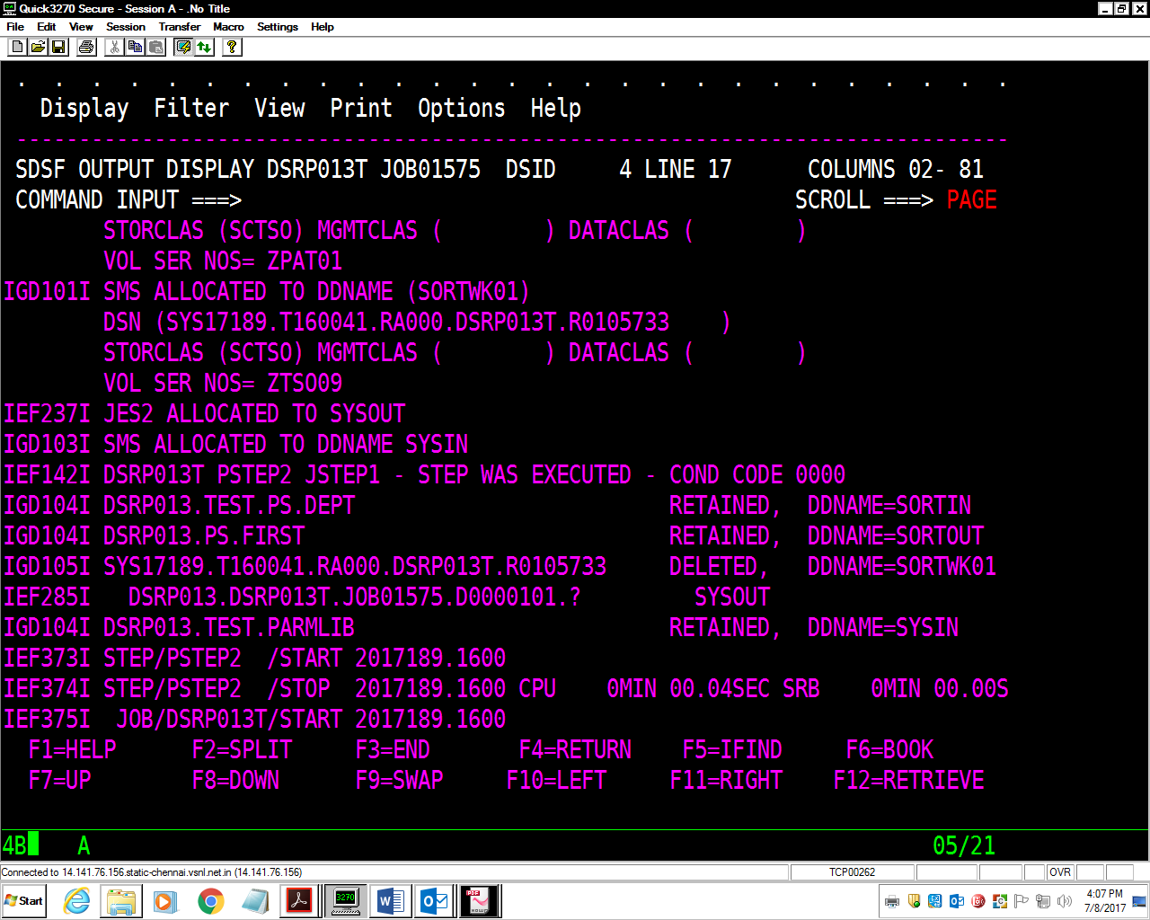

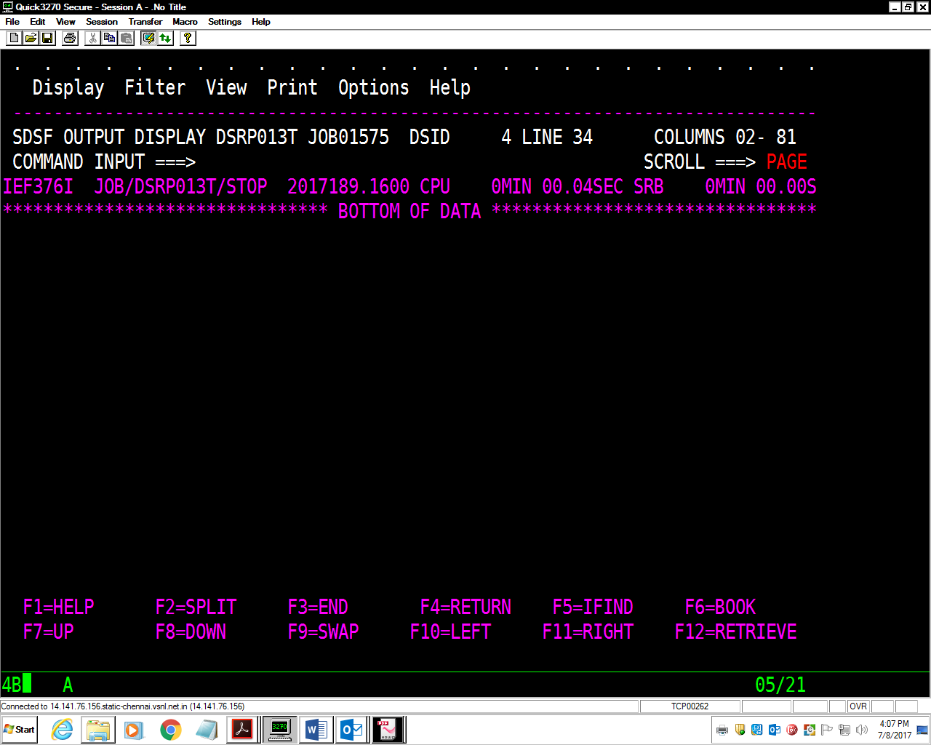

10. Using the ITEM-FILE as Sample Input, write the solution for following

assignments.

**Assignment-1:** Write a JCL to create an output file having unique records (with respect to Item Code column) using the **SORT** utility.

//DSRP013C JOB ABCD,'CAP GEMINI',MSGLEVEL=(1,1),

// MSGCLASS=X,CLASS=A,NOTIFY=&SYSUID

//*

//STEP010 EXEC PGM=IEFBR14

//FILE1 DD DSN=DSRP013.ITEM.OUT,

// DISP=(MOD,DELETE,DELETE),

// SPACE=(TRK,(1,1),RLSE),

// DCB=(LRECL=80,BLKSIZE=8000,RECFM=FB,DSORG=PS)

//*

//STEP020 EXEC PGM=SORT

//SORTIN DD DSN=DSRP013.ITEM.FILE,DISP=OLD

//SORTOUT DD DSN=DSRP013.ITEM.OUT,

// DISP=(NEW,CATLG,DELETE),

// SPACE=(TRK,(1,1),RLSE),

// DCB=(LRECL=80,BLKSIZE=8000,RECFM=FB,DSORG=PS)

//SORTWK01 DD SPACE=(CYL,(1,1),RLSE),UNIT=SYSDA

//SYSOUT DD SYSOUT=*

//SYSIN DD *

SORT FIELDS=(1,5,CH,A)

SUM FIELDS=NONE

/*

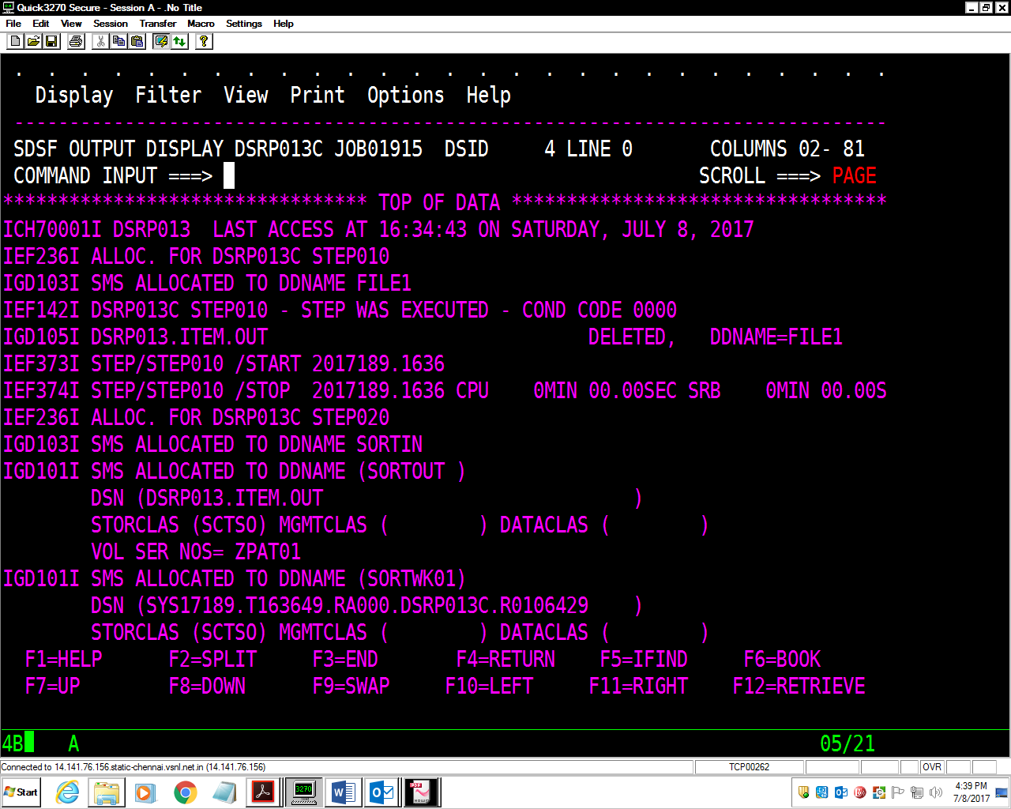

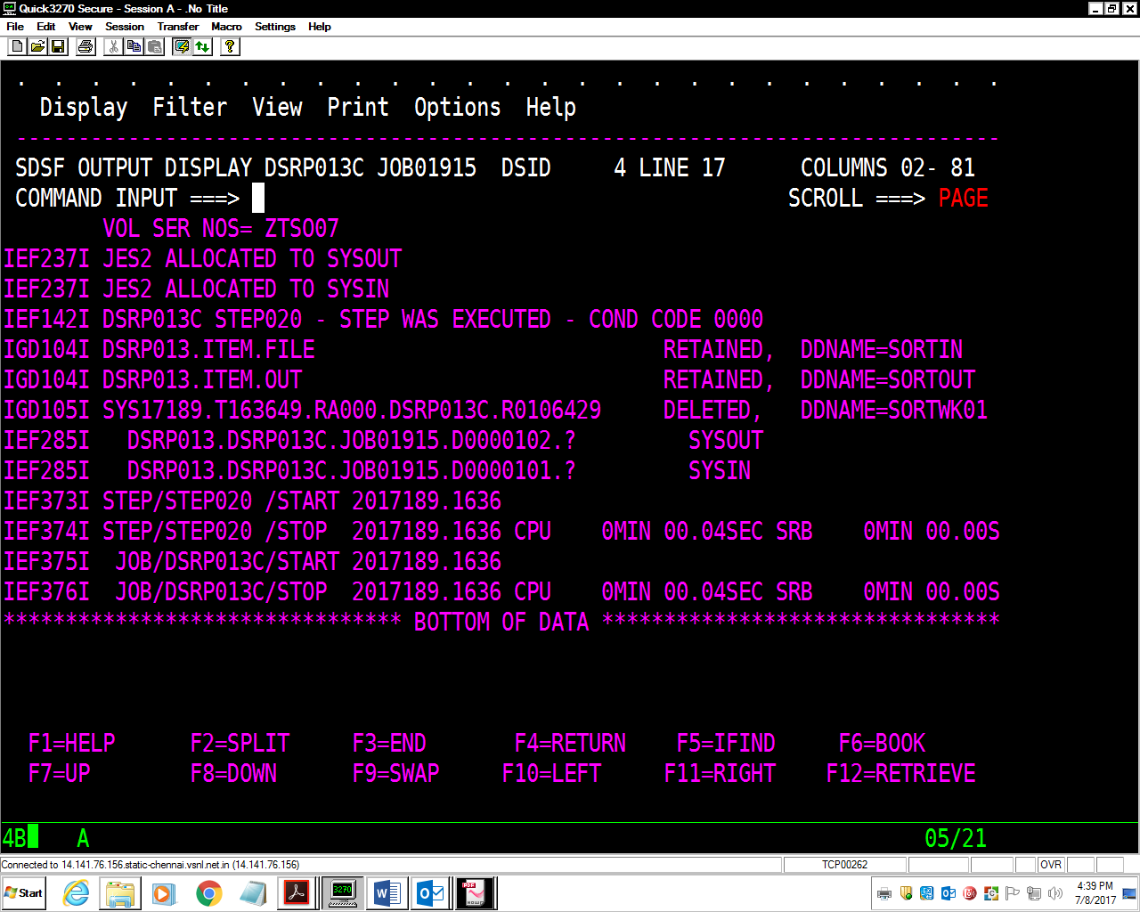

**Assignment-2:** Write a JCL to extract records having Item-code ‘E003’ in new file.

//DSRP013C JOB ABCD,'CAP GEMINI',MSGLEVEL=(1,1),

// MSGCLASS=X,CLASS=A,NOTIFY=&SYSUID

//*

//STEP010 EXEC PGM=IEFBR14

//FILE1 DD DSN=DSRP013.ITEM.OUT1,

// DISP=(MOD,DELETE,DELETE),

// SPACE=(TRK,(1,1),RLSE),

// DCB=(LRECL=80,BLKSIZE=8000,RECFM=FB,DSORG=PS)

//*

//STEP020 EXEC PGM=SORT

//SORTIN DD DSN=DSRP013.ITEM.FILE,DISP=OLD

//SORTOUT DD DSN=DSRP013.ITEM.OUT1,

// DISP=(NEW,CATLG,DELETE),

// SPACE=(TRK,(1,1),RLSE),

// DCB=(LRECL=80,BLKSIZE=8000,RECFM=FB,DSORG=PS)

//SORTWK01 DD SPACE=(CYL,(1,1),RLSE),UNIT=SYSDA

//SYSOUT DD SYSOUT=*

//SYSIN DD *

SORT FIELDS=(1,5,CH,A)

INCLUDE COND=(1,5,CH,EQ,C'E003')

/*

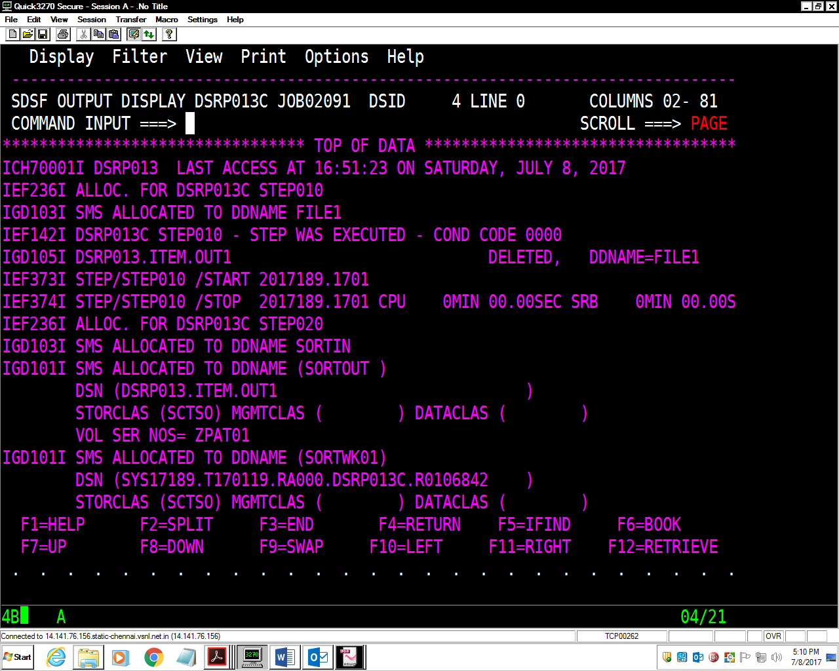

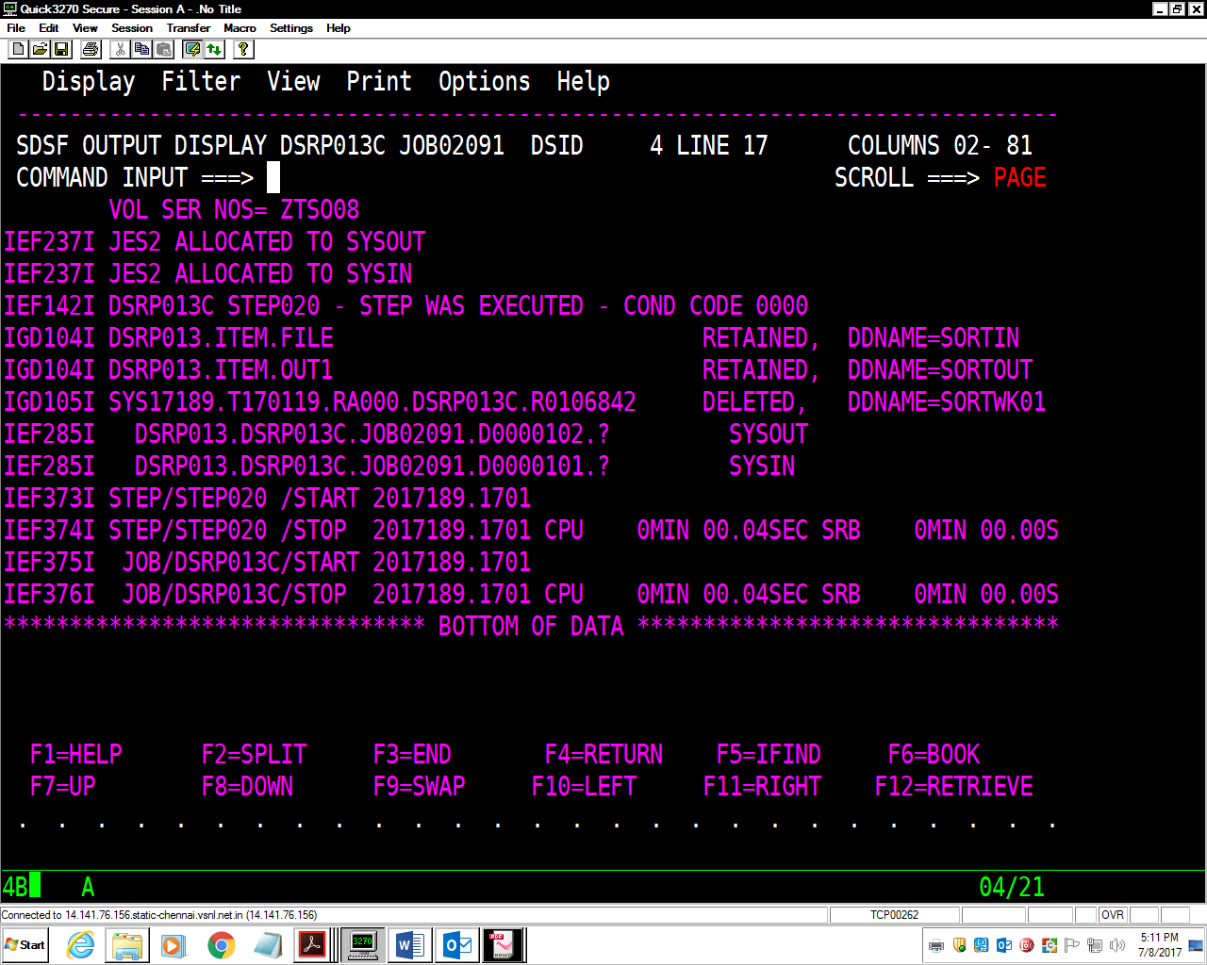

**Assignment-3:** Write a JCL to create a file having only two columns (using

OUTREC) using SORT utility.

[Create Vendor-Item-File having only two fields say Item-Code and Vendor].

//DSRP013C JOB 1234,'MONALI',MSGLEVEL=(1,1),

// MSGCLASS=X,CLASS=A,NOTIFY=&SYSUID

//*

//STEP010 EXEC PGM=IEFBR14

//FILE1 DD DSN=DSRP013.vendor.itemfile,

// DISP=(MOD,DELETE,DELETE),

// SPACE=(TRK,(1,1),RLSE),

// DCB=(LRECL=80,BLKSIZE=8000,RECFM=FB,DSORG=PS)

//*

//STEP020 EXEC PGM=SORT

//SORTIN DD DSN=DSRP013.ITEM.FILE,DISP=OLD

//SORTOUT DD DSN=DSRP013.vendor.itemfile,

// DISP=(NEW,CATLG,DELETE),

// SPACE=(TRK,(1,1),RLSE),

// DCB=(LRECL=80,BLKSIZE=8000,RECFM=FB,DSORG=PS)

//SORTWK01 DD SPACE=(CYL,(1,1),RLSE),UNIT=SYSDA

//SYSOUT DD SYSOUT=*

//SYSIN DD *

SORT FIELDS=(1,5,CH,A)

OUTREC FIELDS=(1:1,4,2X,7:6,6,60X)

/*

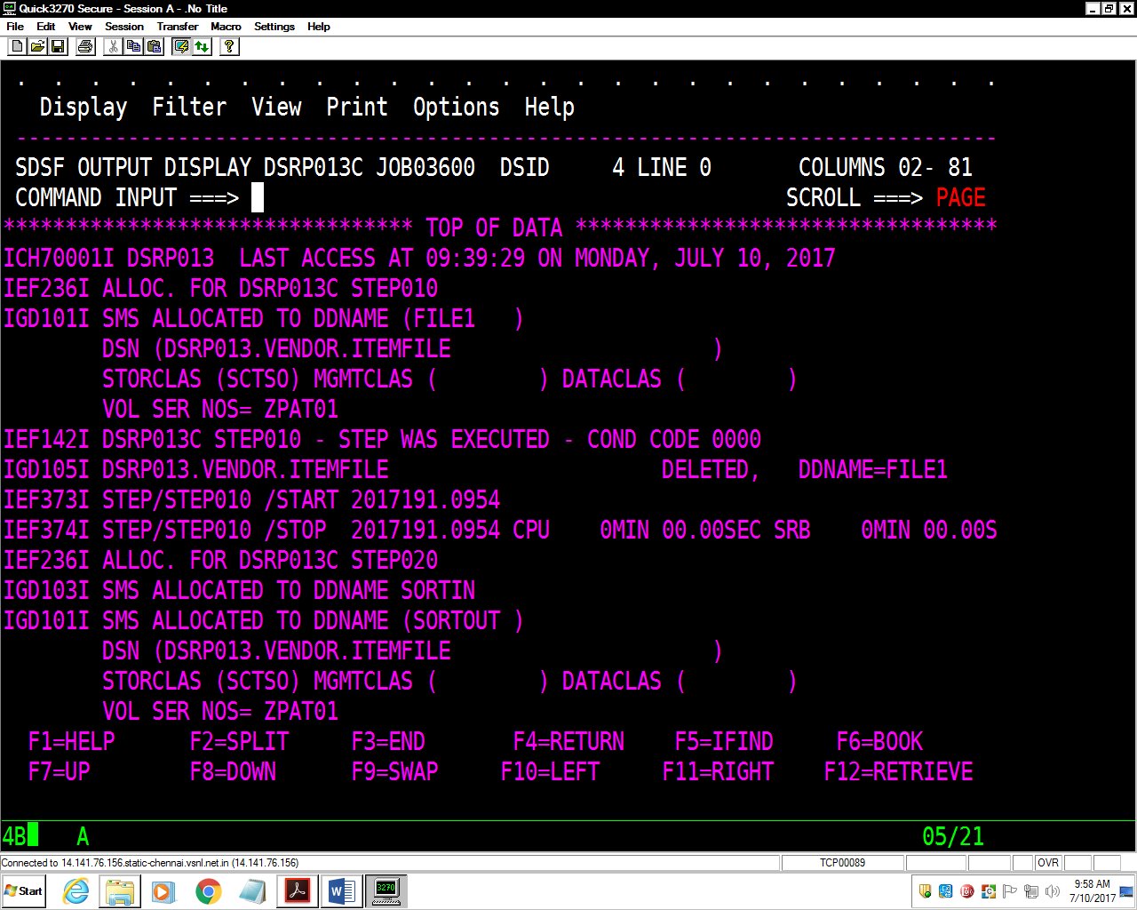

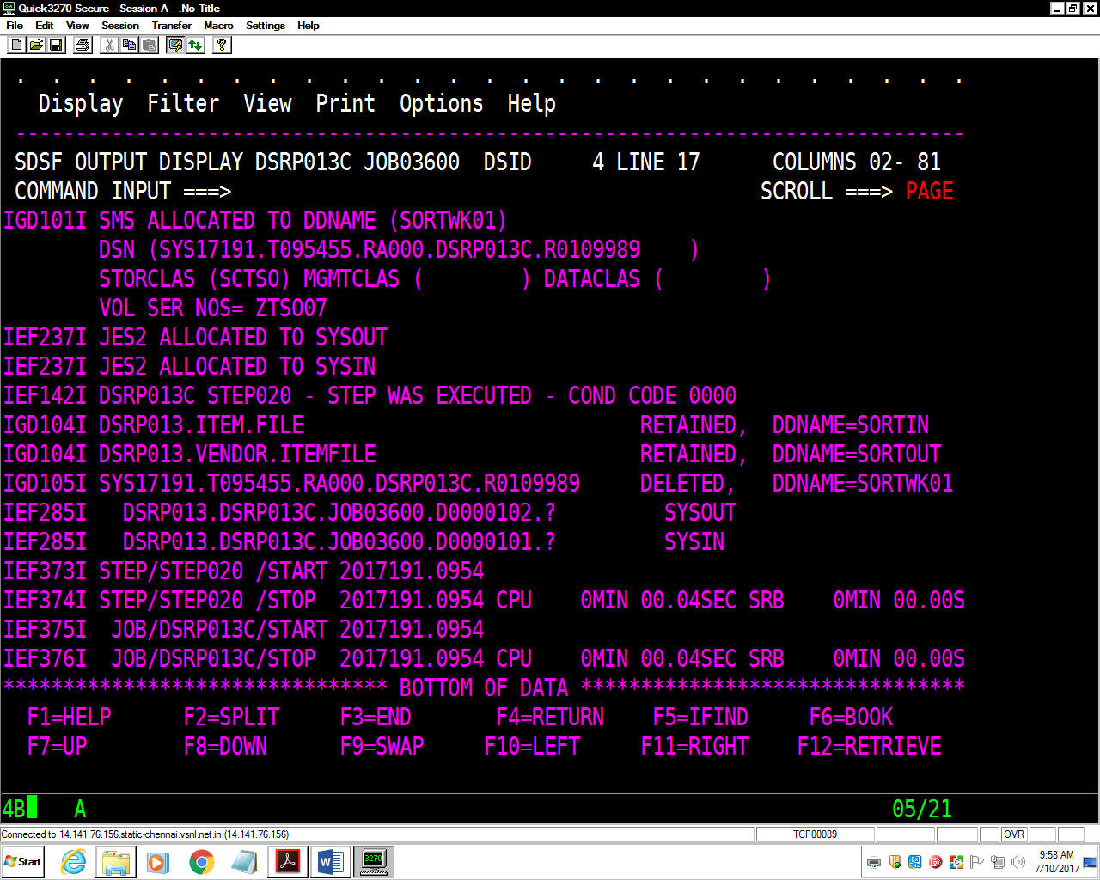

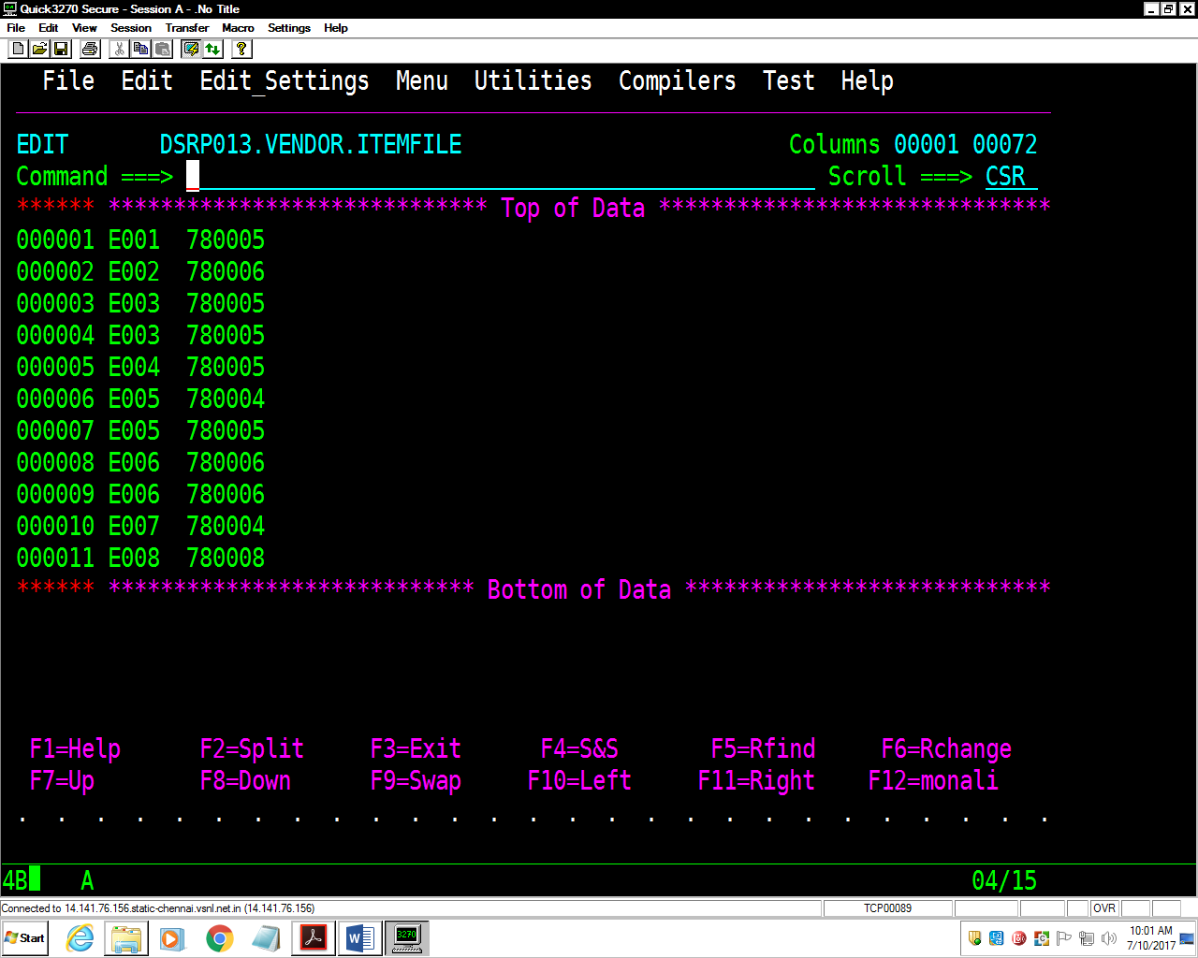

**Assignment-4:** Taking above **Item-File** as input, write a JCL to create another file

(ITEM-FILE-SEQ) having same data and sequence-number as additional column

using **SORT** utility.

//DSRP013C JOB 1234,'MONALI',MSGLEVEL=(1,1),

// MSGCLASS=X,CLASS=A,NOTIFY=&SYSUID

//*

//STEP010 EXEC PGM=IEFBR14

//FILE1 DD DSN=DSRP013.ITEM.FILE.OUT3,

// DISP=(MOD,DELETE,DELETE),

// SPACE=(TRK,(1,1),RLSE),

// DCB=(LRECL=80,BLKSIZE=8000,RECFM=FB,DSORG=PS)

//*

//STEP020 EXEC PGM=SORT

//SORTIN DD DSN=DSRP013.ITEM.FILE,DISP=OLD

//SORTOUT DD DSN=DSRP013.ITEM.FILE.OUT3,

// DISP=(NEW,CATLG,DELETE),

// SPACE=(TRK,(1,1),RLSE),

// DCB=(LRECL=80,BLKSIZE=8000,RECFM=FB,DSORG=PS)

//SORTWK01 DD SPACE=(CYL,(1,1),RLSE),UNIT=SYSDA

//SYSOUT DD SYSOUT=*

//SYSIN DD *

SORT FIELDS=(1,5,CH,A)

OUTREC FIELDS=(1:1,4,1X,6:6,6,1X,13:13,1,1X,15:15,2,1X,SEQNUM,2,ZD)

/*

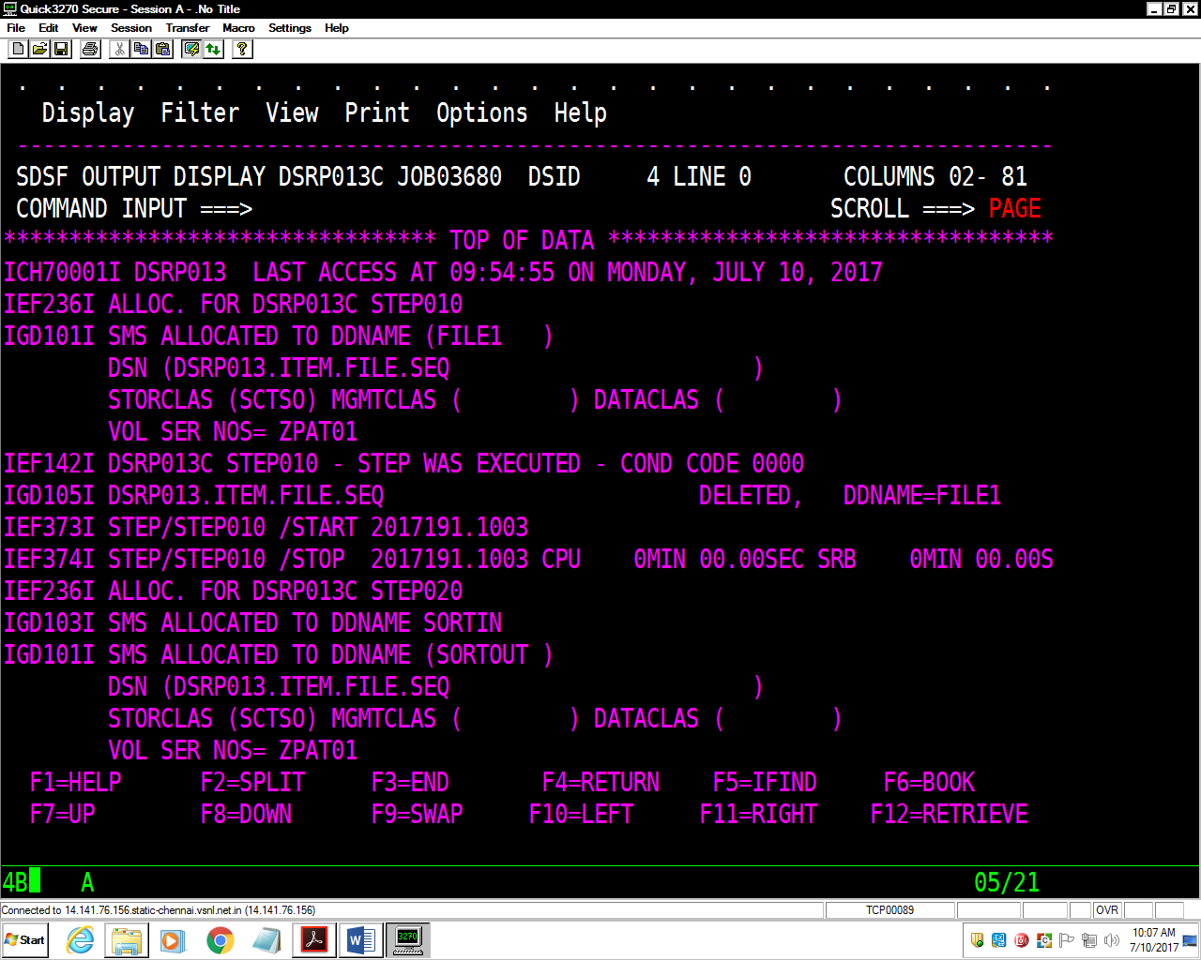

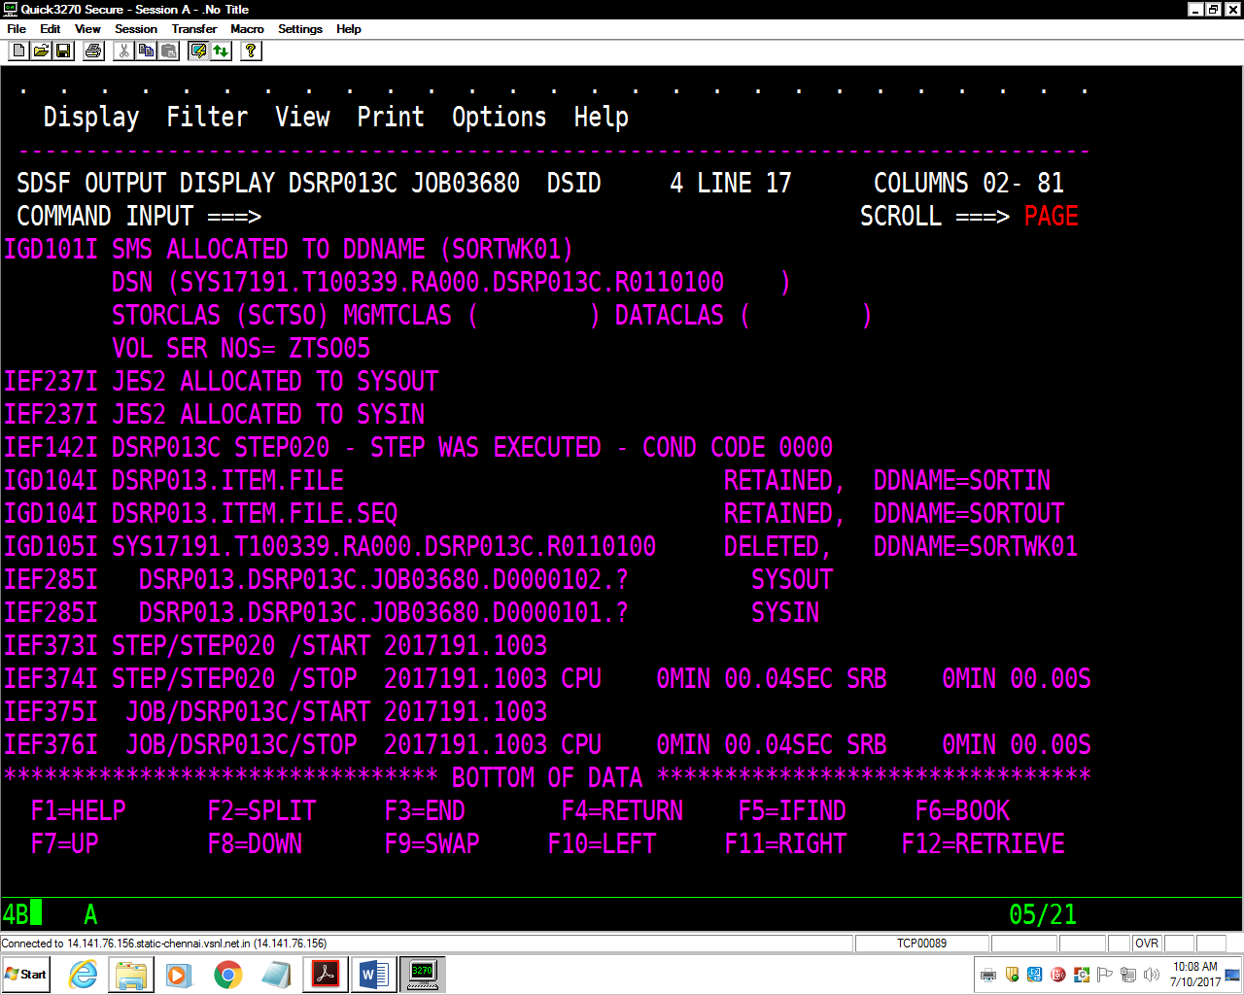

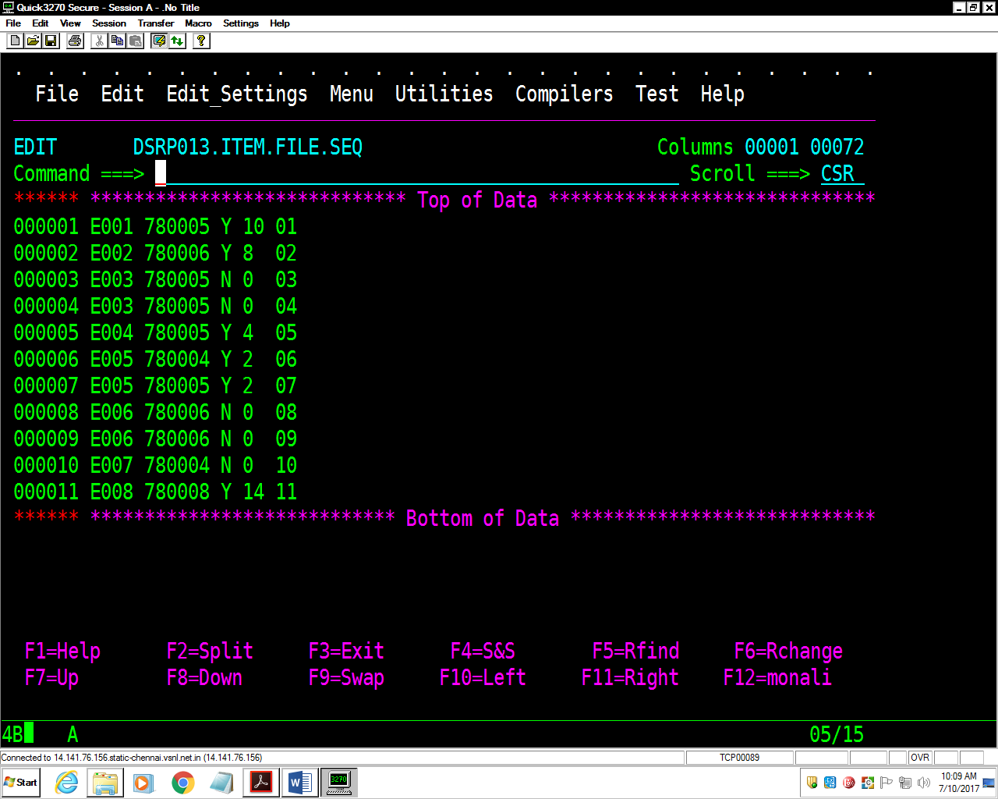

**Assignment-5:** Taking above **Item-File** as input, write a JCL to create another file

(ITEM-FILE-REV) having same records in reverse order of sequence number using

**SORT** utility. (Use **INREC** and **OUTREC**)

Outrec

//DSRP013C JOB 1234,'MONALI',MSGLEVEL=(1,1),

// MSGCLASS=X,CLASS=A,NOTIFY=&SYSUID

//*

//STEP010 EXEC PGM=IEFBR14

//FILE1 DD DSN=DSRP013.ITEM.FILE.REV,

// DISP=(MOD,DELETE,DELETE),

// SPACE=(TRK,(1,1),RLSE),

// DCB=(LRECL=80,BLKSIZE=8000,RECFM=FB,DSORG=PS)

//*

//STEP020 EXEC PGM=SORT

//SORTIN DD DSN=DSRP013.ITEM.FILE.SEQ,DISP=OLD

//SORTOUT DD DSN=DSRP013.ITEM.FILE.REV,

// DISP=(NEW,CATLG,DELETE),

// SPACE=(TRK,(1,1),RLSE),

// DCB=(LRECL=80,BLKSIZE=8000,RECFM=FB,DSORG=PS)

//SORTWK01 DD SPACE=(CYL,(1,1),RLSE),UNIT=SYSDA

//SYSOUT DD SYSOUT=*

//SYSIN DD *

SORT FIELDS=(18,2,CH,D)

OUTREC FIELDS=(1:18,2,3:1,17,52X)

/*

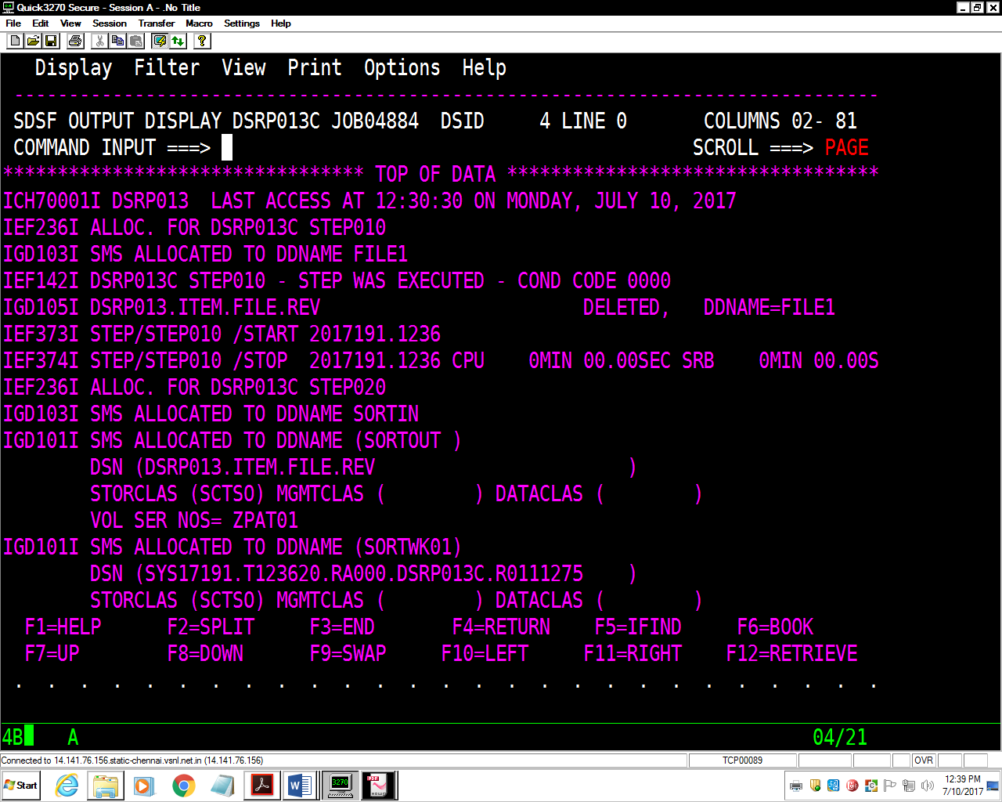

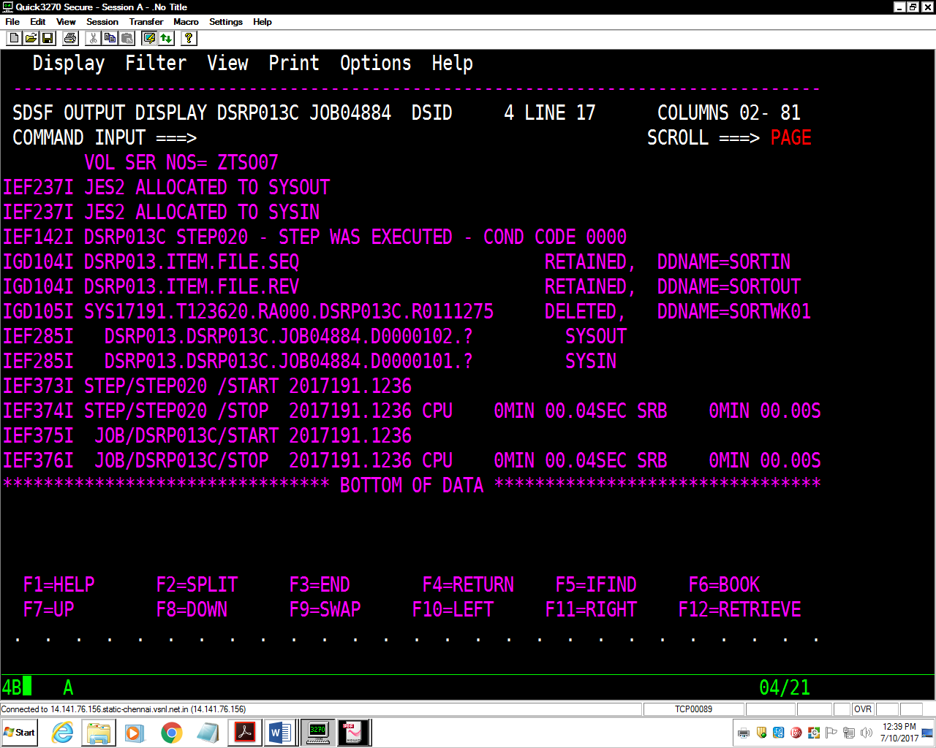

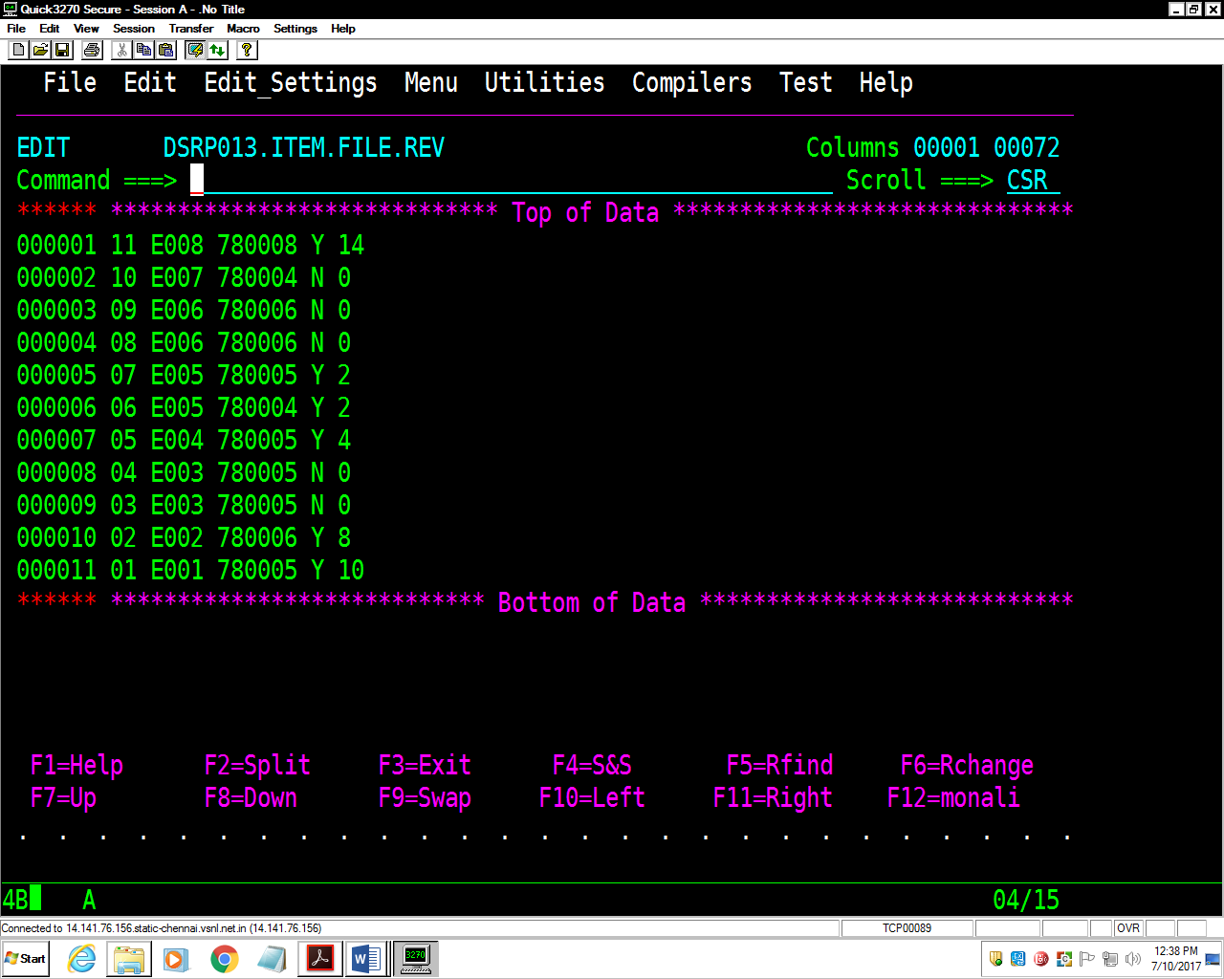

Inrec

//DSRP013C JOB 1234,'MONALI',MSGLEVEL=(1,1),

// MSGCLASS=X,CLASS=A,NOTIFY=&SYSUID

//*

//STEP010 EXEC PGM=IEFBR14

//FILE1 DD DSN=DSRP013.ITEM.FILE.REV,

// DISP=(MOD,DELETE,DELETE),

// SPACE=(TRK,(1,1),RLSE),

// DCB=(LRECL=80,BLKSIZE=8000,RECFM=FB,DSORG=PS)

//*

//STEP020 EXEC PGM=SORT

//SORTIN DD DSN=DSRP013.ITEM.FILE.SEQ,DISP=OLD

//SORTOUT DD DSN=DSRP013.ITEM.FILE.REV,

// DISP=(NEW,CATLG,DELETE),

// SPACE=(TRK,(1,1),RLSE),

// DCB=(LRECL=80,BLKSIZE=8000,RECFM=FB,DSORG=PS)

//SORTWK01 DD SPACE=(CYL,(1,1),RLSE),UNIT=SYSDA

//SYSOUT DD SYSOUT=*

//SYSIN DD *

SORT FIELDS=(1,2,CH,D)

OUTREC FIELDS=(1:18,2,3:1,17)

/*

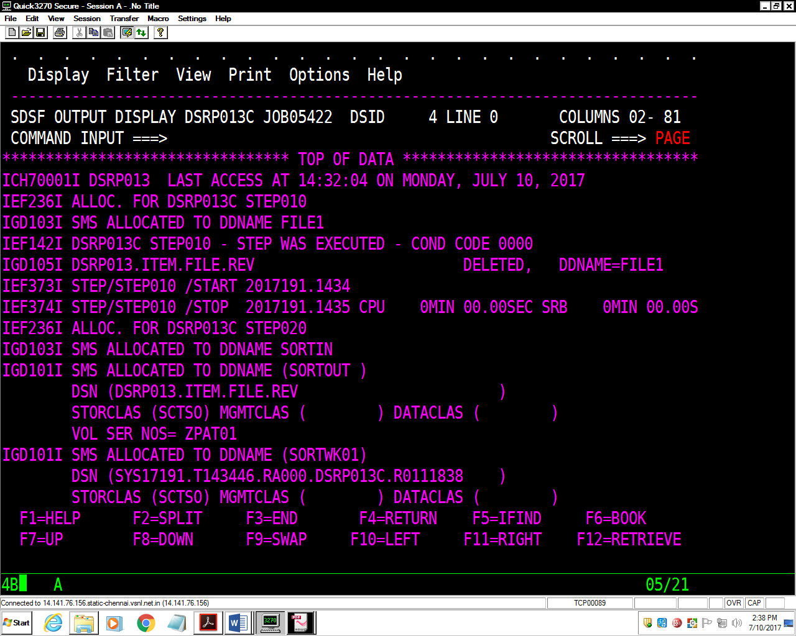

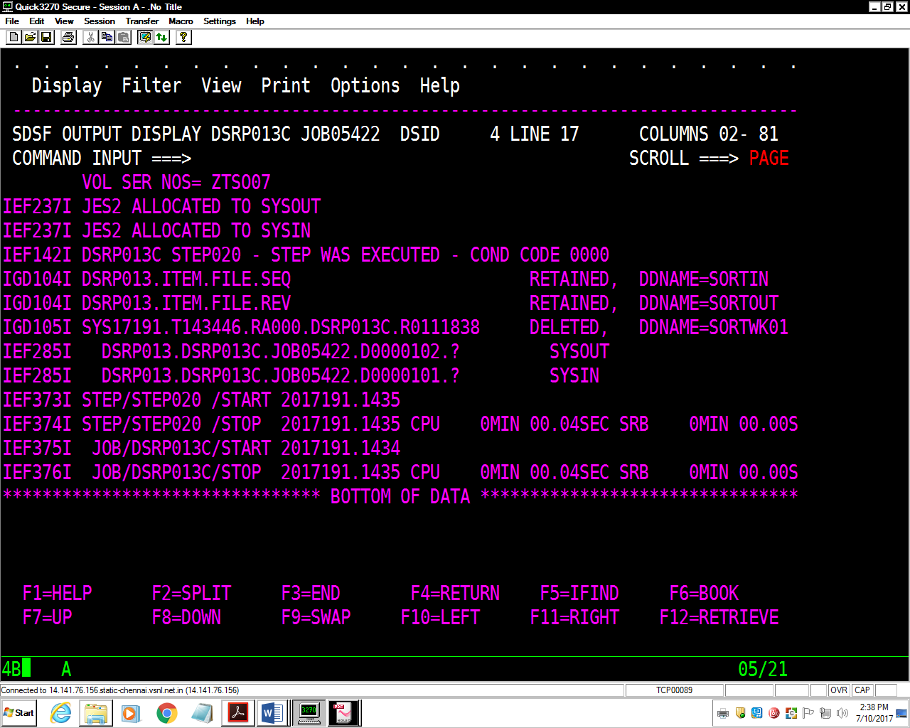

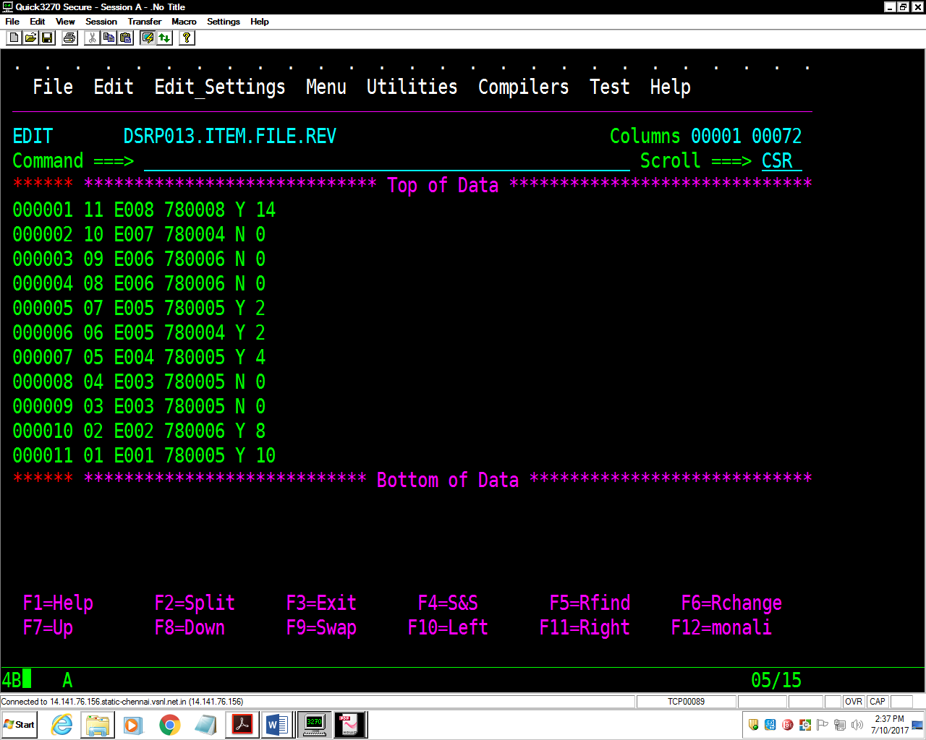

**Assignment-6:** Considering the file created in Lab 5, that is ITEM-FILE, as input,

write a JCL to concatenate these two files into a single file (ITEM-CONCT_FILE)

lengths using **IEBGENER**.

//DSRP013T JOB 1234,'MONALI',MSGLEVEL=(1,1),

// MSGCLASS=X,CLASS=A,NOTIFY=&SYSUID

//*

//STEP1 EXEC PGM=IEFBR14

//FILE1 DD DSN=DSRP013.ITEM.CONCT.FILE,

// DISP=(MOD,DELETE,DELETE),

// SPACE=(TRK,(1,1),RLSE),

// DCB=(LRECL=80,BLKSIZE=27920,RECFM=FB,DSORG=PS)

//*

//STEP2 EXEC PGM=IEBGENER

//SYSUT1 DD DSN=DSRP013.ITEM.FILE,DISP=OLD

// DD DSN=DSRP013.ITEM.FILE.OUT4,DISP=OLD

//SYSUT2 DD DSN=DSRP013.ITEM.CONCT.FILE,

// DISP=(MOD,CATLG,DELETE),

// SPACE=(TRK,(1,1),RLSE),

// DCB=(LRECL=80,BLKSIZE=27920,RECFM=FB,DSORG=PS)

//SYSPRINT DD SYSOUT=*

//SYSIN DD *

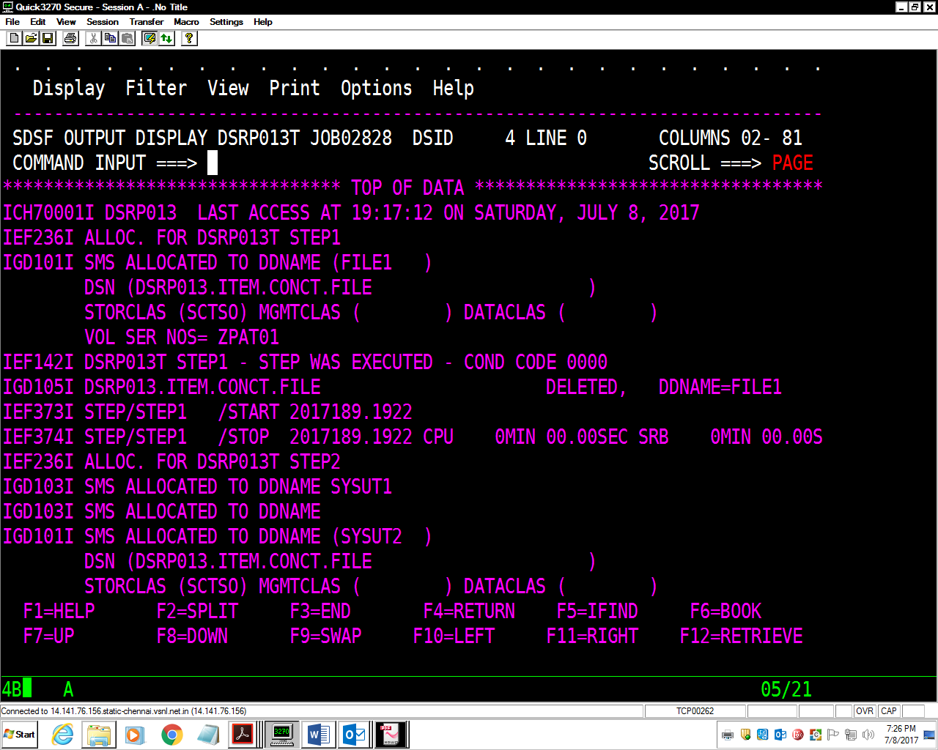

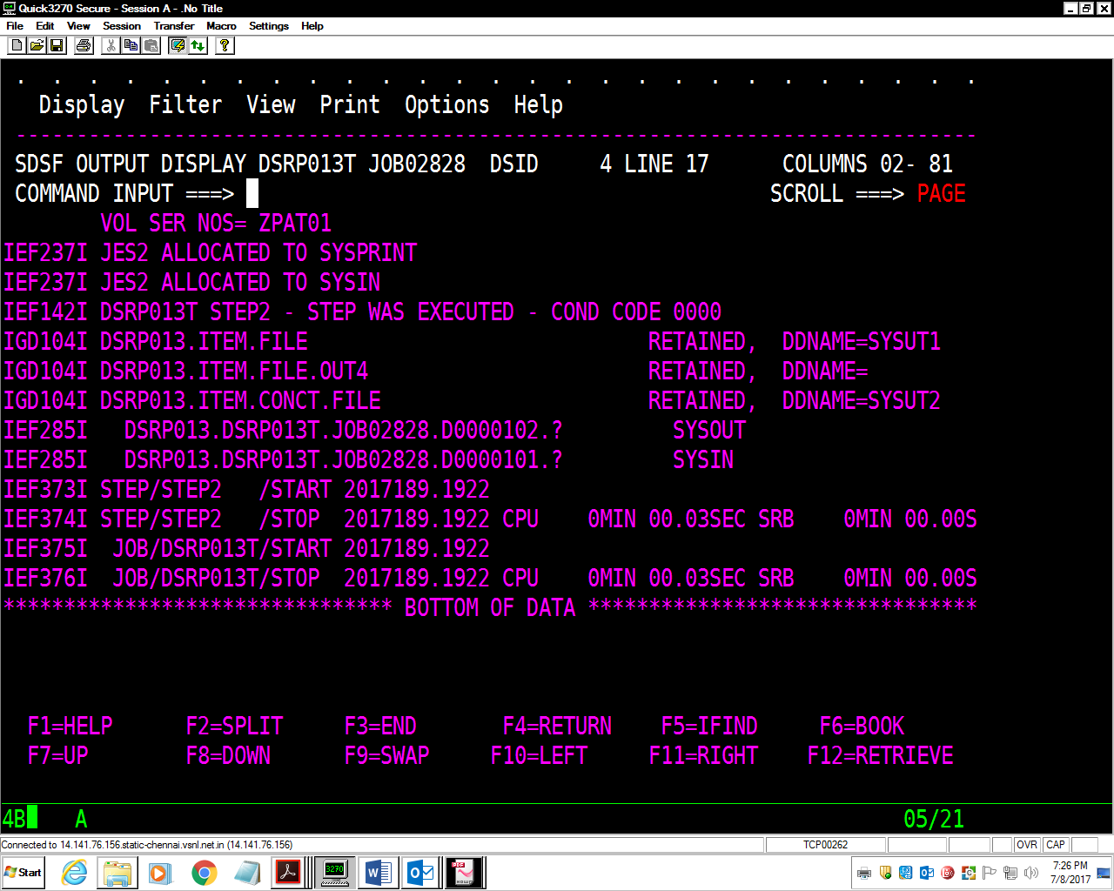

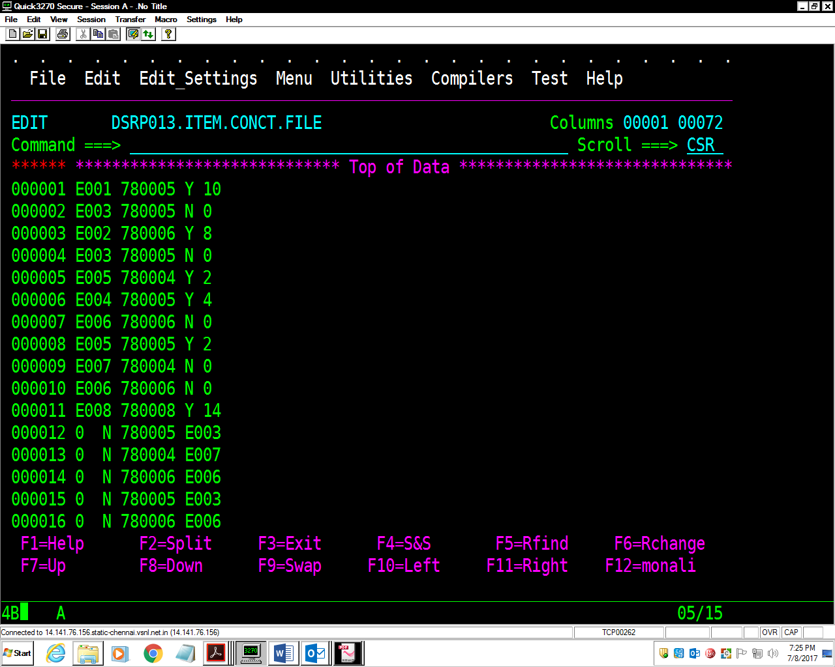

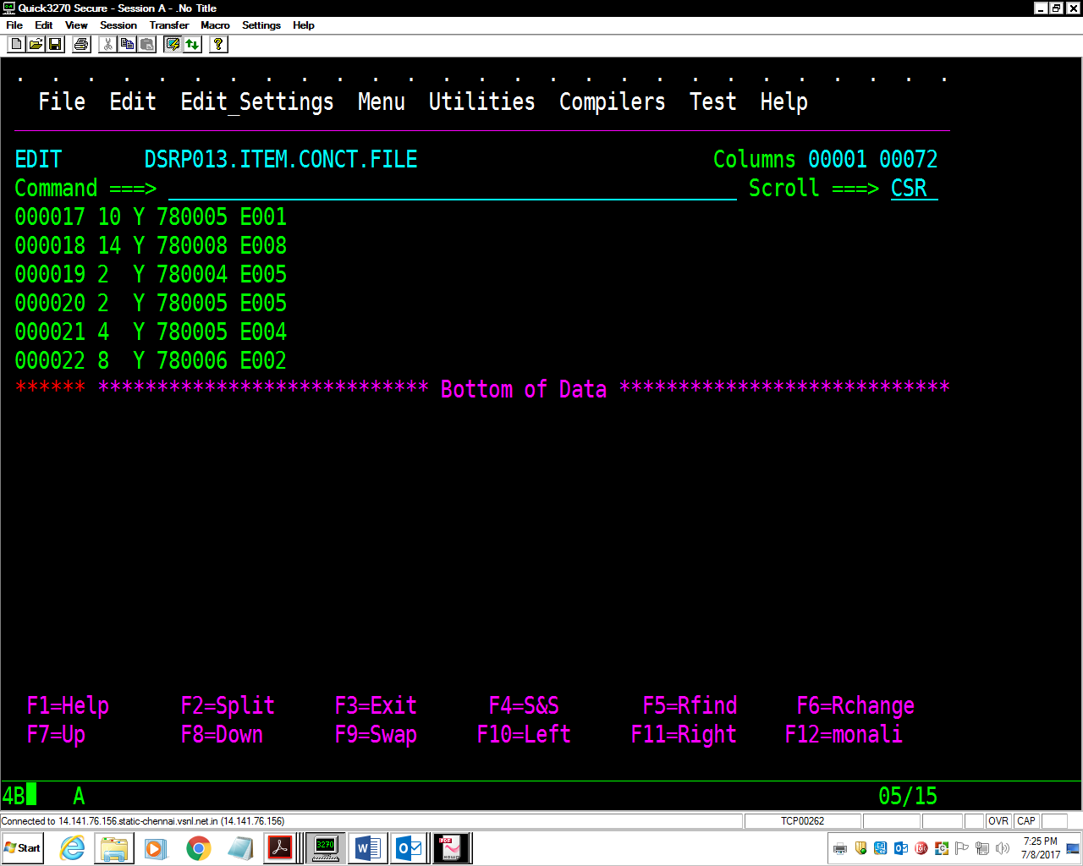

**Assignment-7:** Taking above **Item-File** as input, write a **Job** to skip the first 3

records and copying next 4 subsequent records into a new dataset (ITEM-FILE-4R)

using SORT utility.

//DSRP013M JOB 1234,'MONALI',MSGLEVEL=(1,1),

// MSGCLASS=X,CLASS=A,NOTIFY=&SYSUID

//*

//STEP010 EXEC PGM=IEFBR14

//FILE1 DD DSN=DSRP013.ITEM.FILE4R,

// DISP=(MOD,DELETE,DELETE),

// SPACE=(TRK,(1,1),RLSE),

// DCB=(LRECL=80,BLKSIZE=8000,RECFM=FB,DSORG=PS)

//*

//STEP020 EXEC PGM=SORT

//SORTIN DD DSN=DSRP013.ITEM.FILE,DISP=OLD

//SORTOUT DD DSN=DSRP013.ITEM.FILE4R,

// DISP=(NEW,CATLG,DELETE),

// SPACE=(TRK,(1,1),RLSE),

// DCB=(LRECL=80,BLKSIZE=8000,RECFM=FB,DSORG=PS)

//SORTWK01 DD SPACE=(TRK,(1,1),RLSE),UNIT=SYSDA

//SYSOUT DD SYSOUT=*

//SYSIN DD *

SORT FIELDS=(1,3,CH,A),

SKIPREC=3,STOPAFT=4

/*

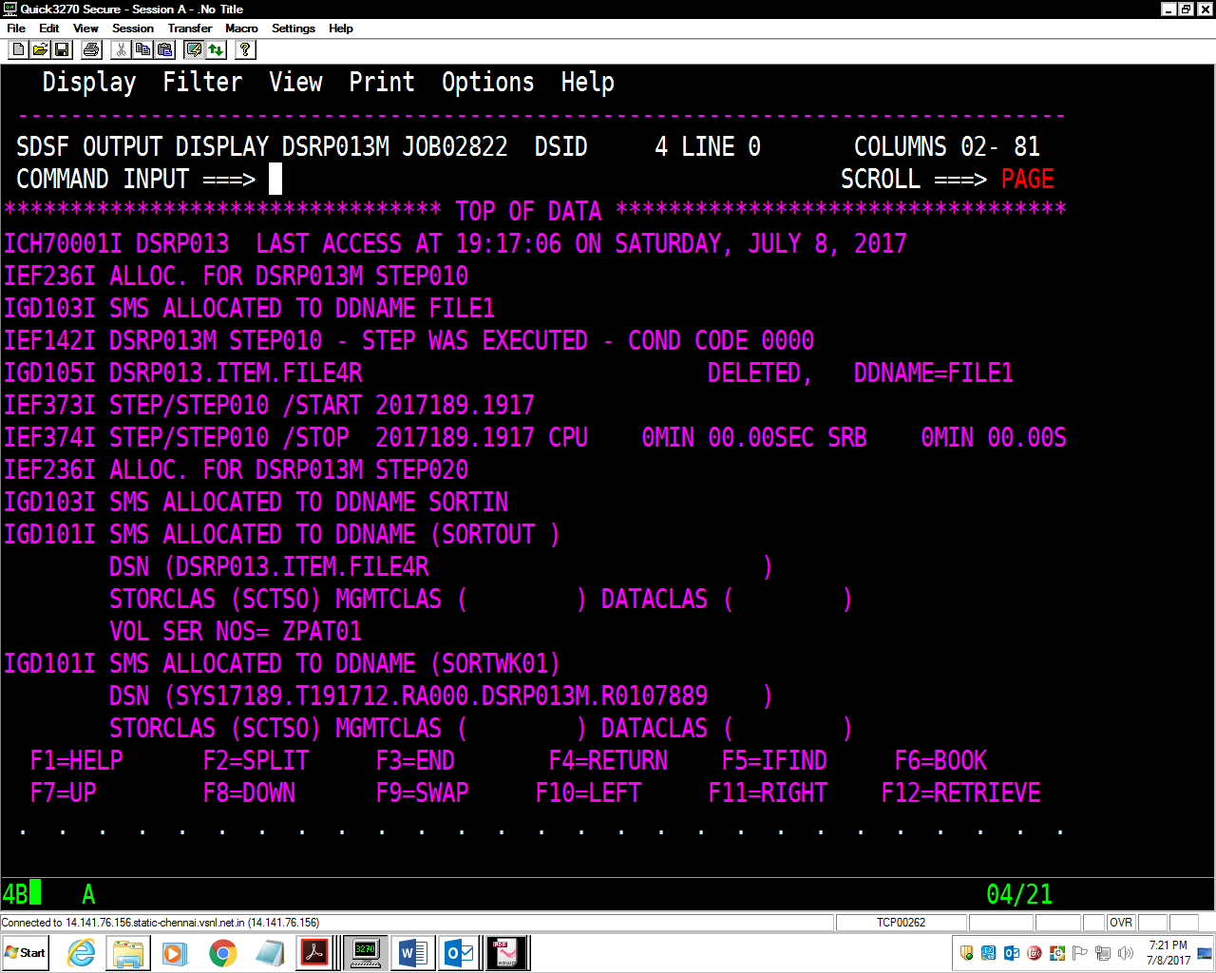

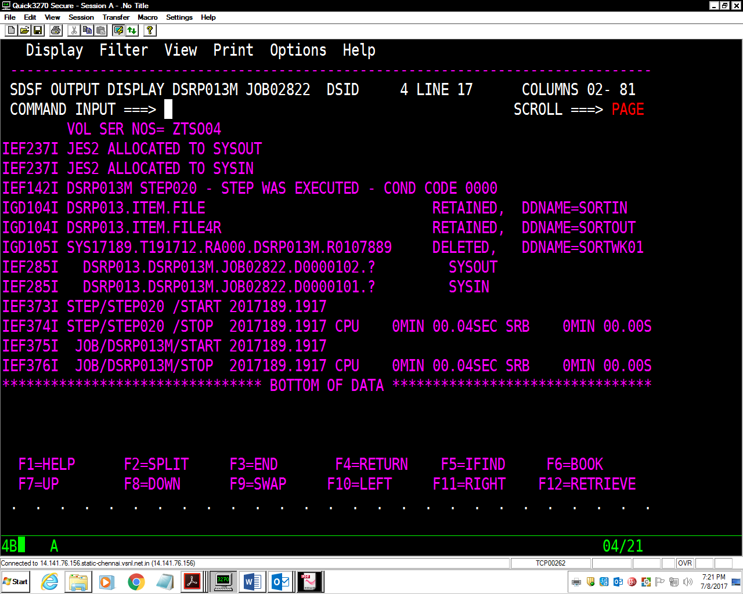

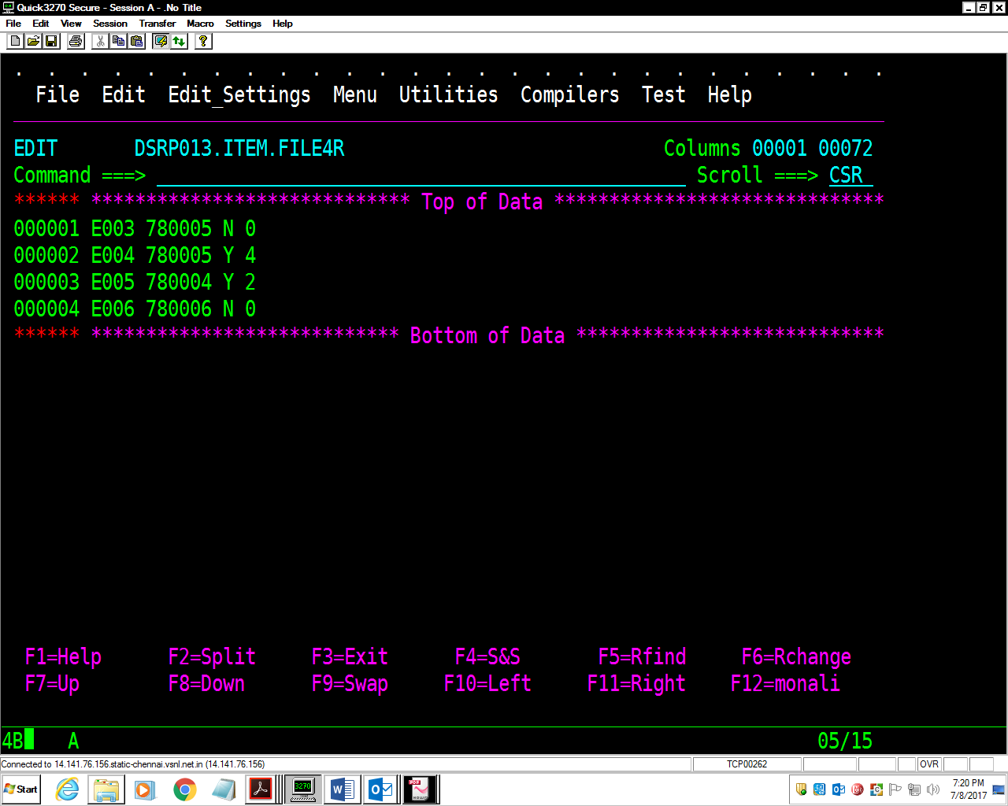

11.Write a JCL that will create new PDS USerid.MyPDS and will be cataloged on

successful execution of the step and dataset will be deleted if job terminates

abnormally.

//DSRP013T JOB 1234,'MONALI',MSGLEVEL=(1,1),

// MSGCLASS=X,CLASS=A,NOTIFY=&SYSUID

//*

//STEP1 EXEC PGM=IEFBR14

//FILE1 DD DSN=DSRP013.MYPDS,

// DISP=(MOD,DELETE,DELETE),

// SPACE=(TRK,(1,1),RLSE),

// DCB=(LRECL=80,BLKSIZE=27920,RECFM=FB,DSORG=PS)

//*

//STEP2 EXEC PGM=IEFBR14

//FILE2 DD DSN=DSRP013.MYPDS,

// DISP=(NEW,CATLG,DELETE),

// SPACE=(TRK,(1,1),RLSE),

// DCB=(LRECL=80,BLKSIZE=8000,RECFM=FB,DSORG=PS)

/*

